**VISVESVARAYA TECHNOLOGICAL UNIVERSITY**

**“JnanaSangama”, Belgaum -590014, Karnataka.**



**LAB REPORT**

**on**

**Object Oriented Java Programming (23CS3PCOOJ)**

***Submitted by***

**Shreya Jaganatha Gowda**

**(1BM23IC061)**

***in partial fulfillment for the award of the degree of***

**BACHELOR OF ENGINEERING**

***in***

**COMPUTER SCIENCE AND ENGINEERING**



**B.M.S. COLLEGE OF ENGINEERING**

**(Autonomous Institution under VTU)**

**BENGALURU-560019**

**Sep-2024 to Jan-2025**

**B.M.S. College of Engineering,**

**Bull Temple Road, Bangalore 560019**

(Affiliated To Visvesvaraya Technological University, Belgaum)

**Department of Computer Science and Engineering**



**CERTIFICATE**

This is to certify that the Lab work entitled “Object Oriented Java Programming (23CS3PCOOJ)” carried out by **Shreya Jaganatha Gowda (1BM23IC061),** who is bonafide student of **B.M.S. College of Engineering.** It is in partial fulfillment for the award of **Bachelor of Engineering in Computer Science and Engineering** of the Visvesvaraya Technological University, Belgaum. The Lab report has been approved as it satisfies the academic requirements in respect of an Object Oriented Java Programming (23CS3PCOOJ) work prescribed for the said degree.

| Dr.Prasad G R  Professor  Department of CSE, BMSCE | Dr. Jyothi S Nayak  Professor & HOD  Department of CSE, BMSCE |
| --- | --- |

**Index**

| **Sl.**  **No.** | **Date** | **Experiment Title** | **Page No.** |
| --- | --- | --- | --- |
| 1 | 09.10.24 | QUADRATIC EQUATION | 4. |
| 2 | 16.10.24 | SGPA CALCULATOR | 9. |
| 3 | 23.10.24 | BOOK CLASS | 15. |
| 4 | 23.10.24 | SHAPE AREA | 22. |
| 5 | 30.10.24 | BANK ACCOUNT | 27. |
| 6 | 13.11.24 | SEE MARKS | 38. |
| 7 | 20.11.24 | FATHER SON AGE | 48. |
| 8 | 27.11.24 | THREADS | 55. |
| 9 | 27.11.24 | USER INTERFACE | 60. |
| 10 | 27.11.24 | INTERPROCESS COMMUNICATION AND DEADLOCK | 66. |

Name:Shreya Jaganatha Gowda

USN:1BM23IC061

Github Link:

<https://github.com/Shreyajg/JAVAlab>

**Program 1**

Implement Quadratic Equation

Algorithm:

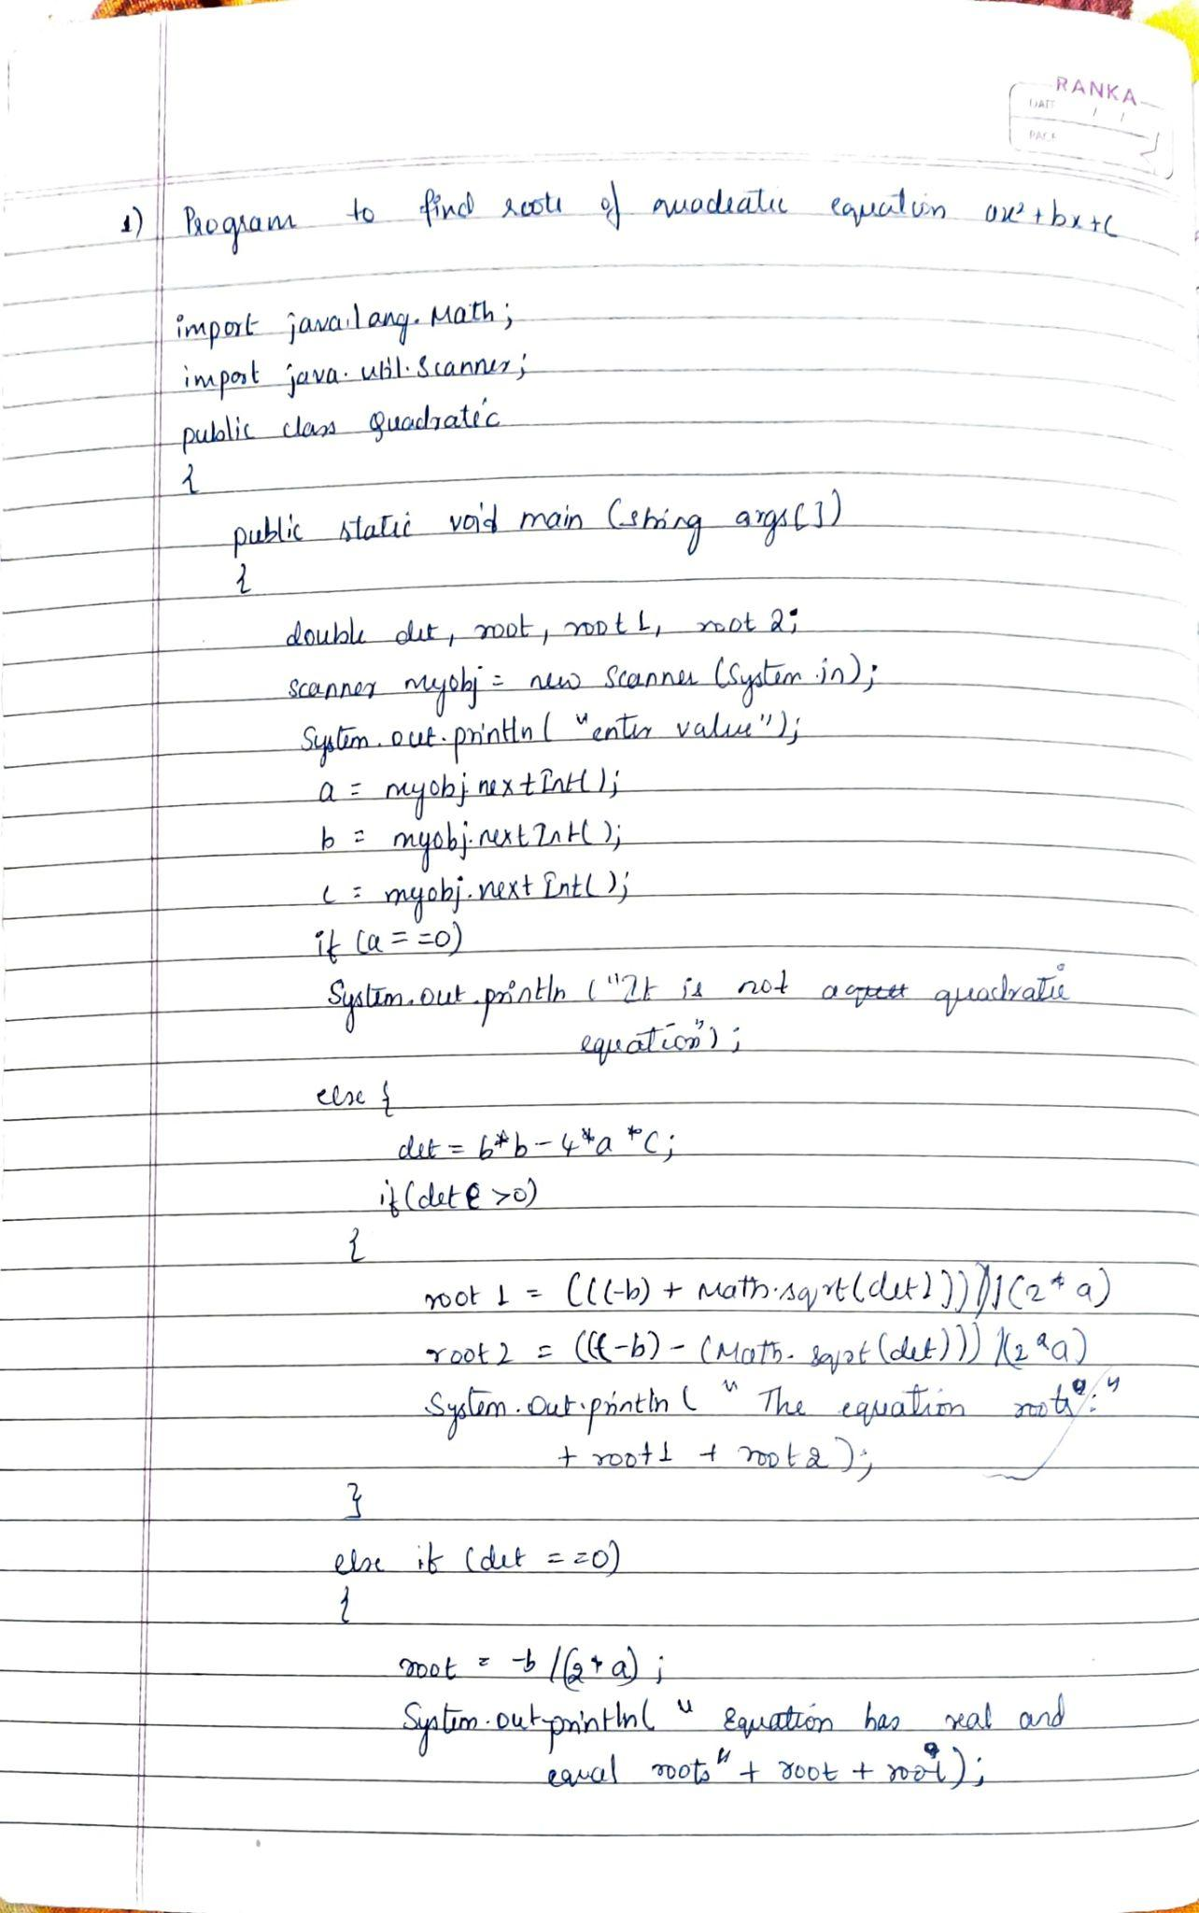

Code: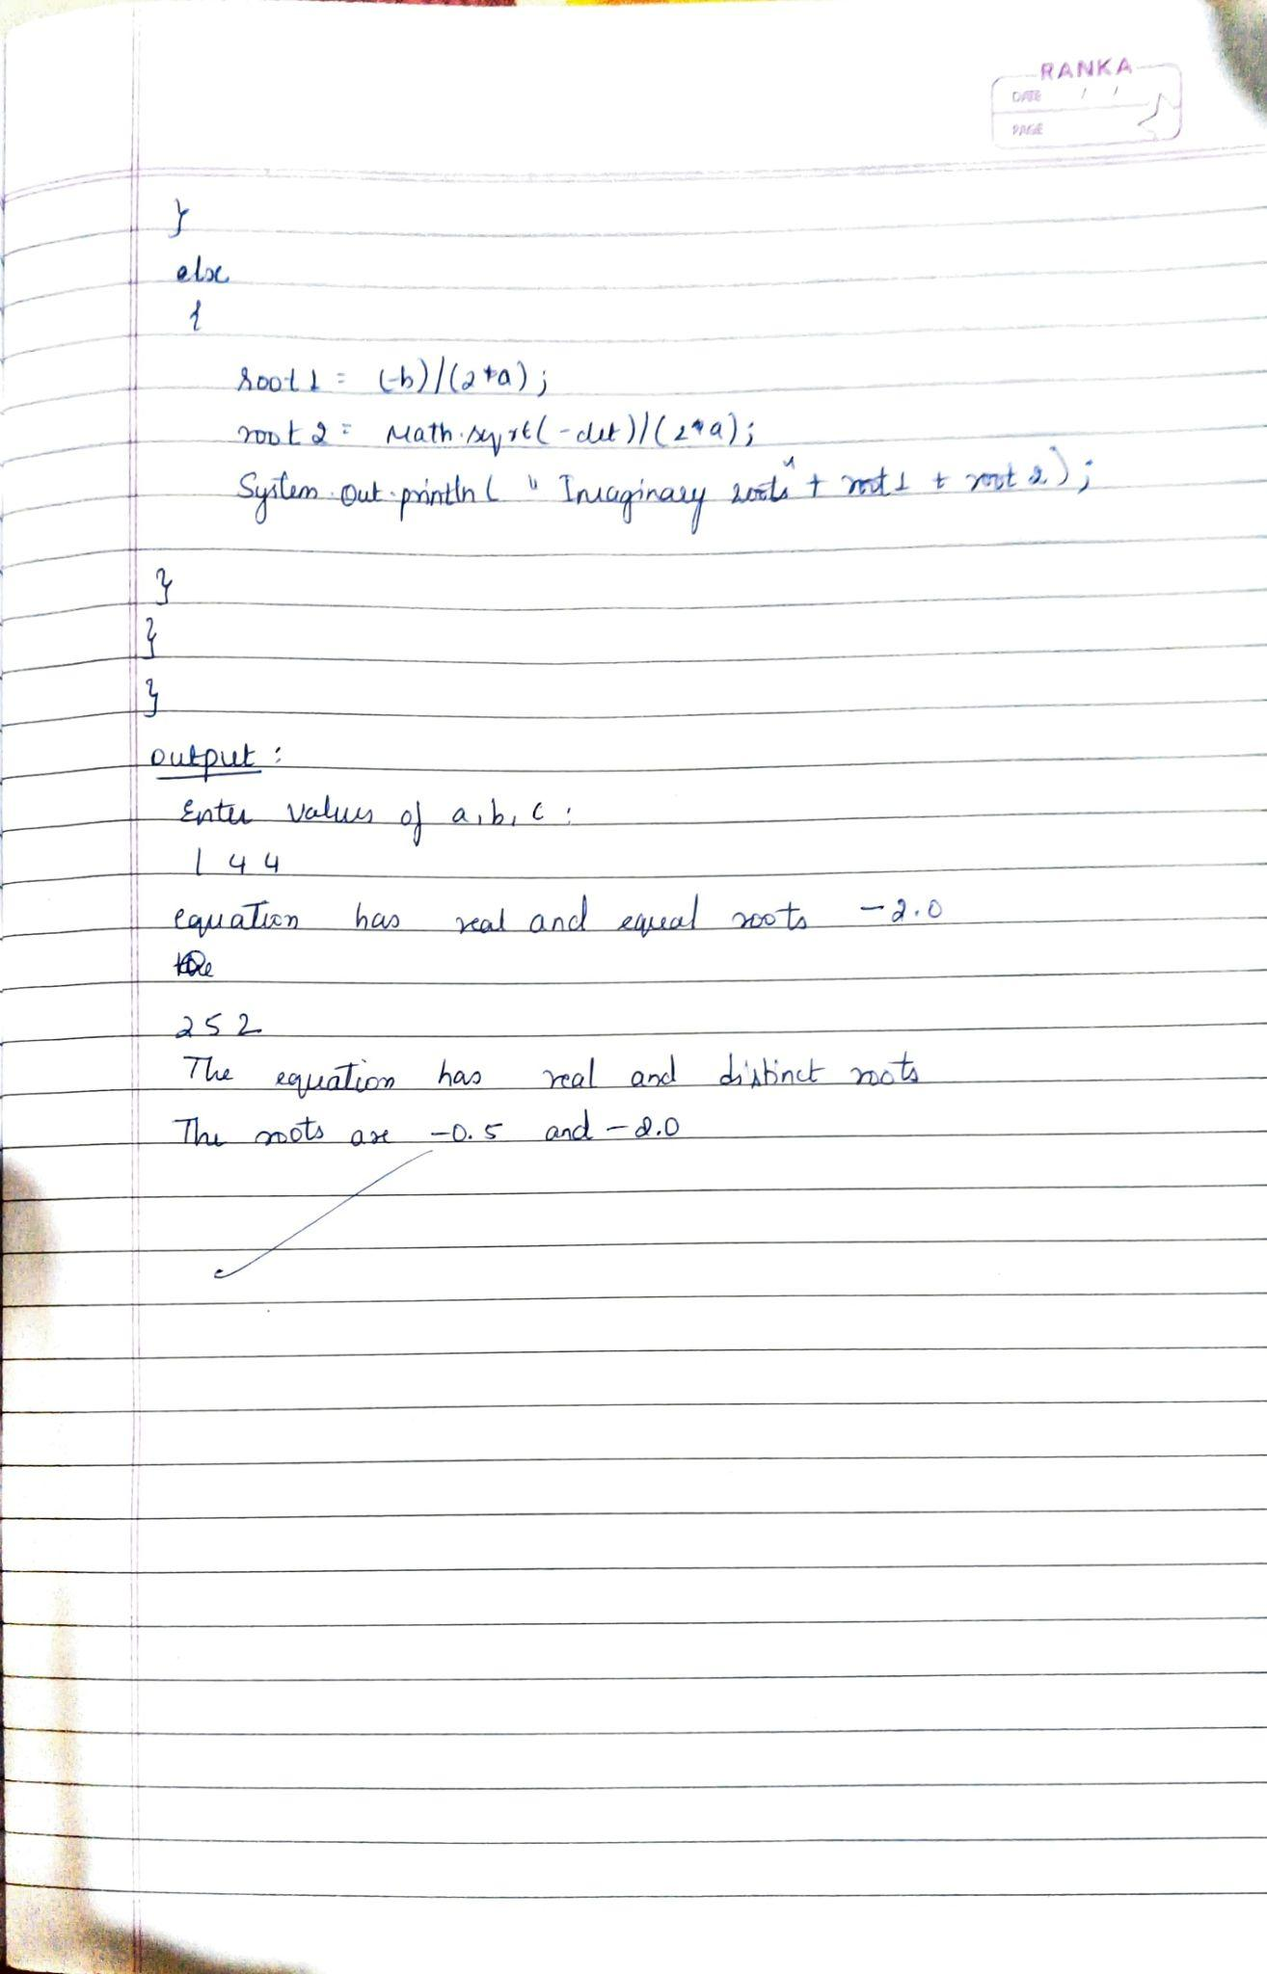

import java.util.Scanner;

import java.lang.Math;

class quadratic

{

public static void main(String args[])

{

int a,b,c;

double det,root,root1,root2;

Scanner myobj=new Scanner(System.in);

System.out.println("my name is Shreya");

System.out.println("my usn is 1BM23IC061");

System.out.println("Enter the values of a,b,c:");

a=myobj.nextInt();

b=myobj.nextInt();

c=myobj.nextInt();

if(a==0)

{

System.out.println("It is not a quadratic equation");

}

else

{

det=(b*b)-(4*a*c);

if(det>0)

{

root1=(((-b)+(Math.sqrt(det)))/(2*a));

root2=(((-b)-(Math.sqrt(det)))/(2*a));

System.out.println("It equation has real and distinct roots");

System.out.println("The roots are"+root1+"and"+root2);

}

else if(det==0)

{

root=-b/(2*a);

System.out.println("It equation has real and equal roots");

System.out.println("The roots are"+root);

}

else

{

root1=(-b)/(2*a);

root2=Math.sqrt(-det)/(2*a);

System.out.println("It equation has imaginary roots");

System.out.println("The root 1 is"+root1+"+i"+root2);

System.out.println("The root 2 is"+root1+"-i"+root2);

}

}

}

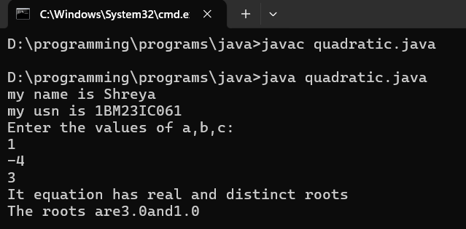

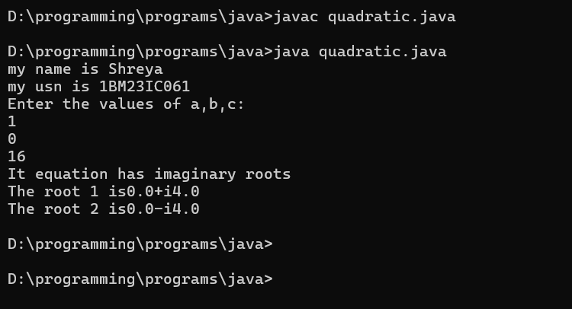

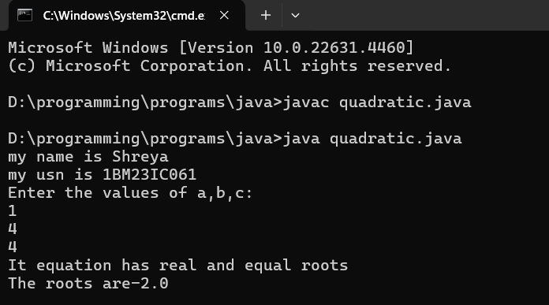

**Program 2**

Calculate the SGPA of a student

Algorithm:

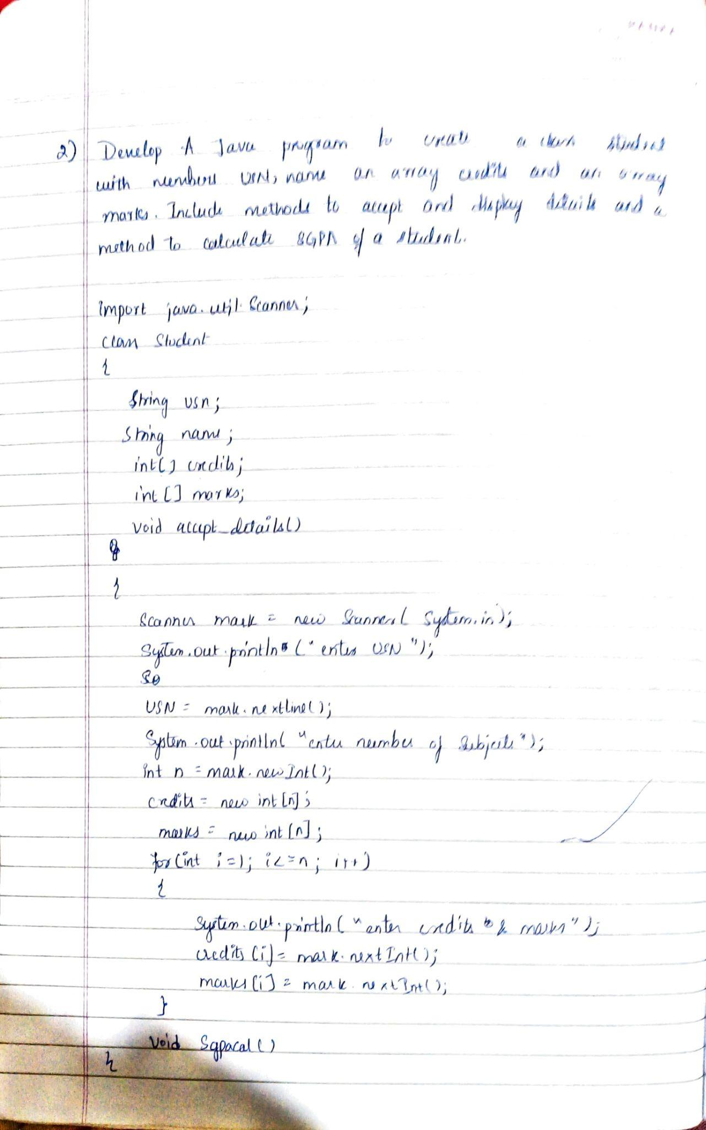

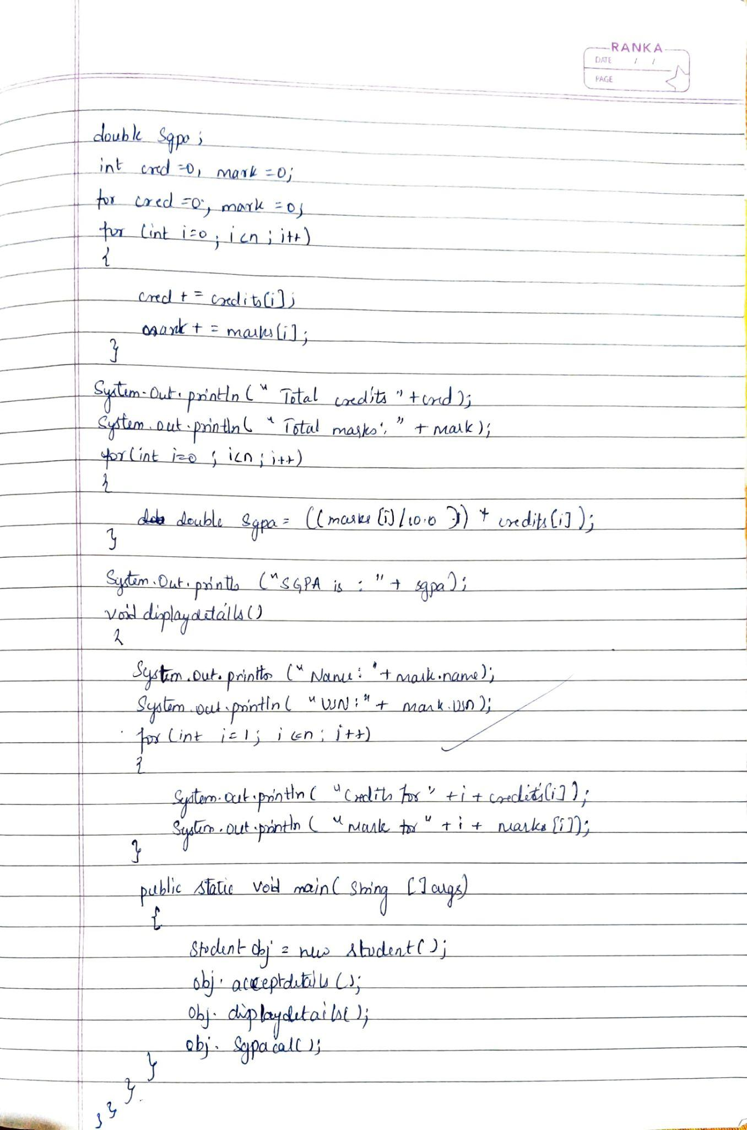

Code:

import java.util.*;

class Stud_det {

int m[] = new int[8];

int c[] = new int[8];

int p[] = new int[8];

int g, sum;

String name, usn;

double sgpa;

Scanner s = new Scanner(System.in);

void getdetails()

{

System.out.println("My name is Shreya");

System.out.println("My usn is 1BM23IC061");

System.out.println("Enter name:");

name = s.next();

System.out.println("Enter usn:");

usn = s.next();

for (int i = 0; i < 8; i++) {

System.out.println("Enter marks of subject:"+(i+1));

m[i] = s.nextInt();

System.out.println("Enter credits for subject:"+(i+1));

c[i] = s.nextInt();

}

}

void gradepoint() {

for (int i = 0; i < 8; i++) {

if (m[i] >= 90 && m[i] <= 100)

p[i] = 10;

else if (m[i] >= 80 && m[i] < 90)

p[i] = 9;

else if (m[i] >= 70 && m[i] < 80)

p[i] = 8;

else if (m[i] >= 60 && m[i] < 70)

p[i] = 7;

else if (m[i] >= 50 && m[i] < 60)

p[i] = 6;

else if (m[i] >= 40 && m[i] < 50)

p[i] = 5;

else

p[i] = 0;

}

}

void calculate() {

for (int i = 0; i < 8; i++) {

g += c[i] * p[i];

}

for (int i = 0; i < 8; i++) {

sum += c[i];

}

sgpa = g / sum;

}

void display() {

System.out.println("Name:" + name);

System.out.println("USN:" + usn);

System.out.println("SGPA=:" + sgpa);

}

}

class student {

public static void main(String a[]){

Stud_det s1[]=new Stud_det[3];

for(int i=0;i<3;i++)

{

s1[i]=new Stud_det();

}

for(int i=0;i<3;i++)

{

System.out.println("Enter details of student:"+(i+1));

s1[i].getdetails();

}

for(int i=0;i<3;i++)

{

s1[i].gradepoint();

s1[i].calculate();

}

for(int i=0;i<3;i++)

{

System.out.println("Student-"+(i+1));

s1[i].display();

}

}

}

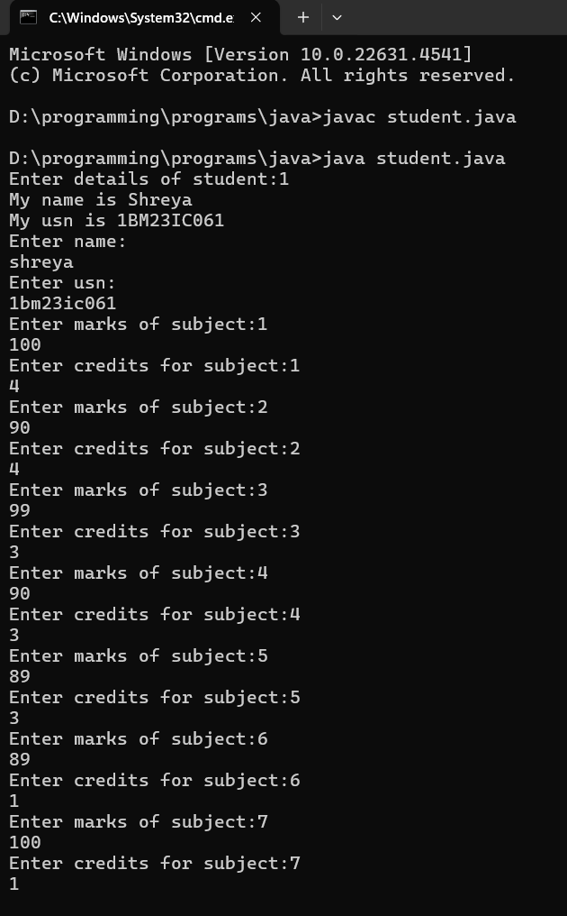

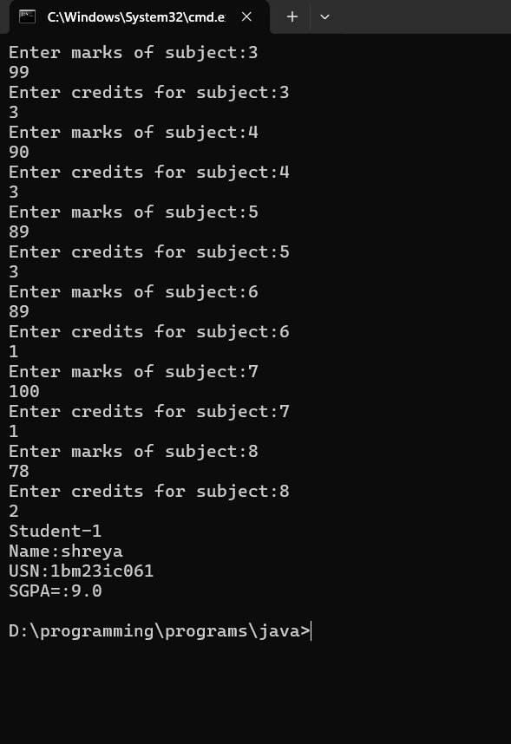

**Program 3**

Create a class Book which contains four members: name, author,price, num_pages. Include a constructor to set the values for the members. Include methods to set and get the details of the objects.Include a toString( ) method that could display the complete details of the book. Develop a Java program to create n book objects.

Algorithm:

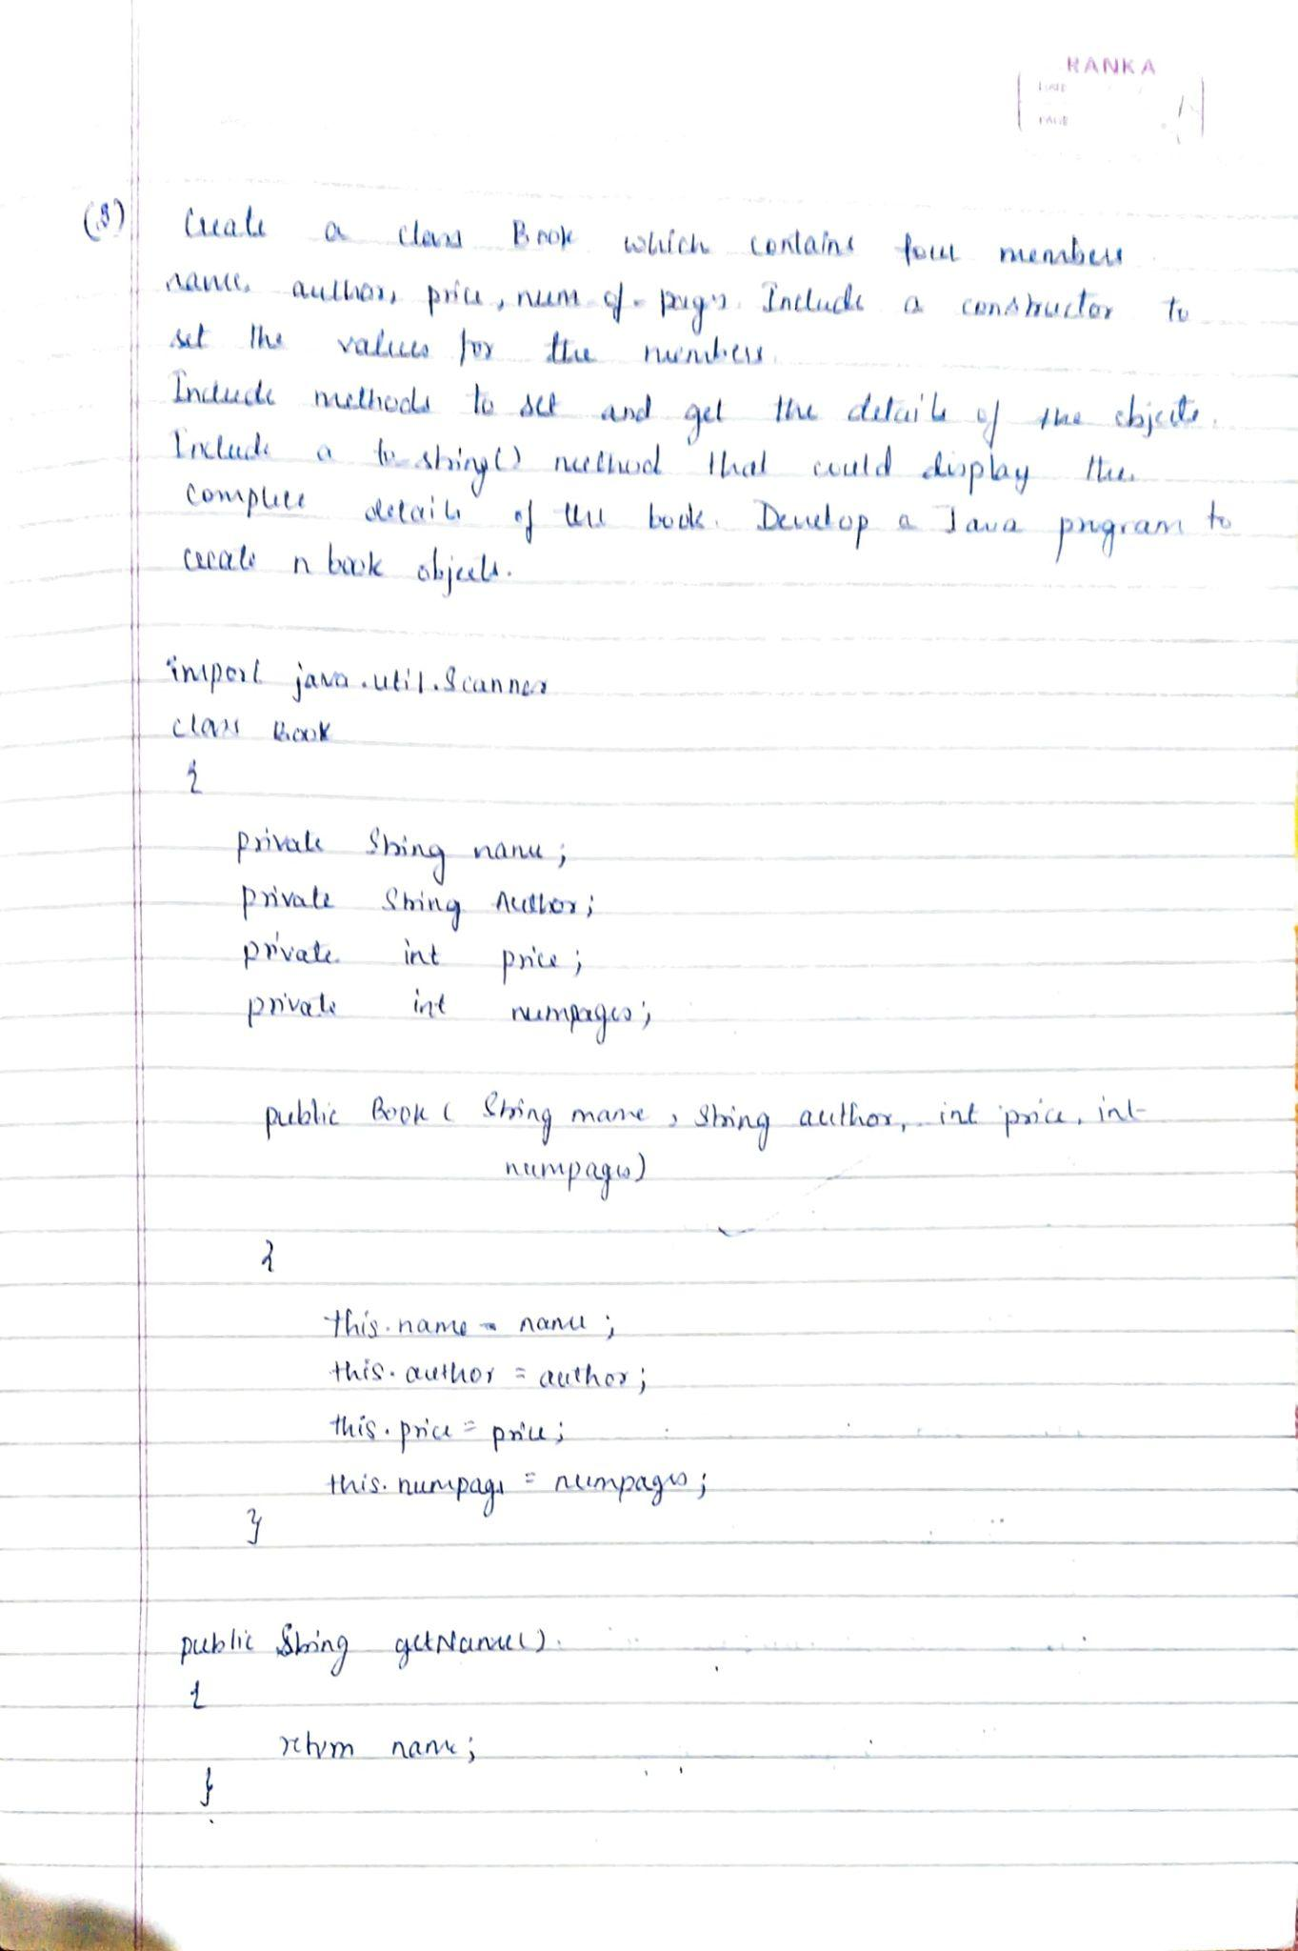

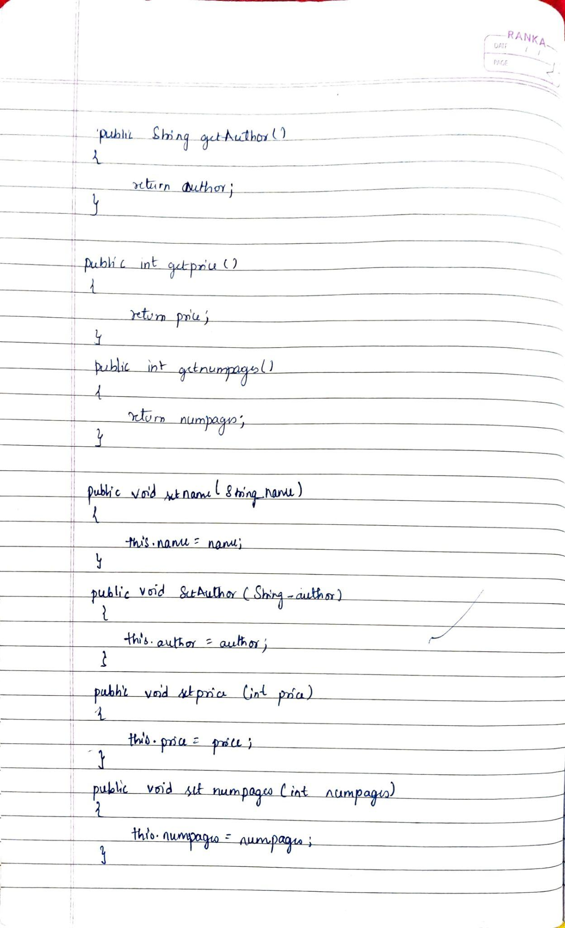

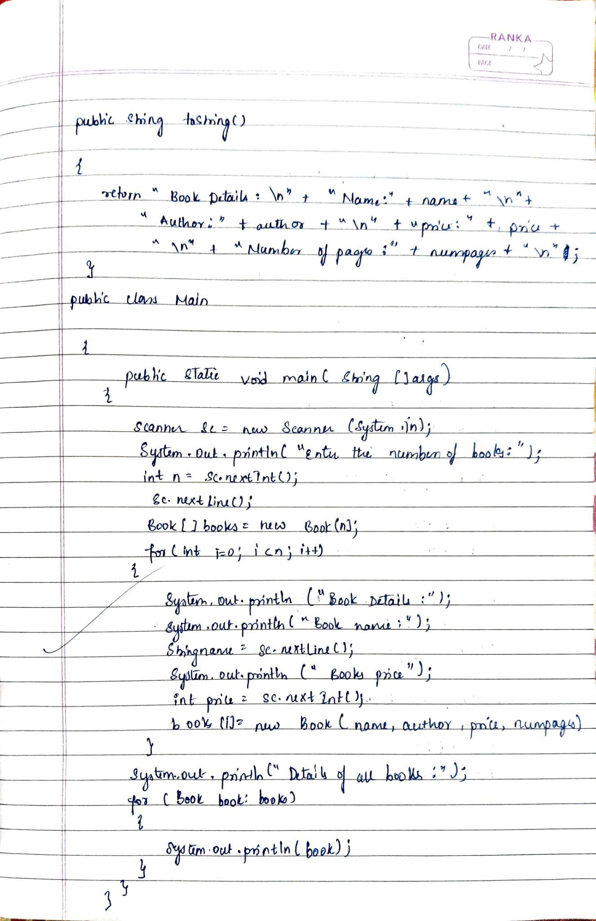

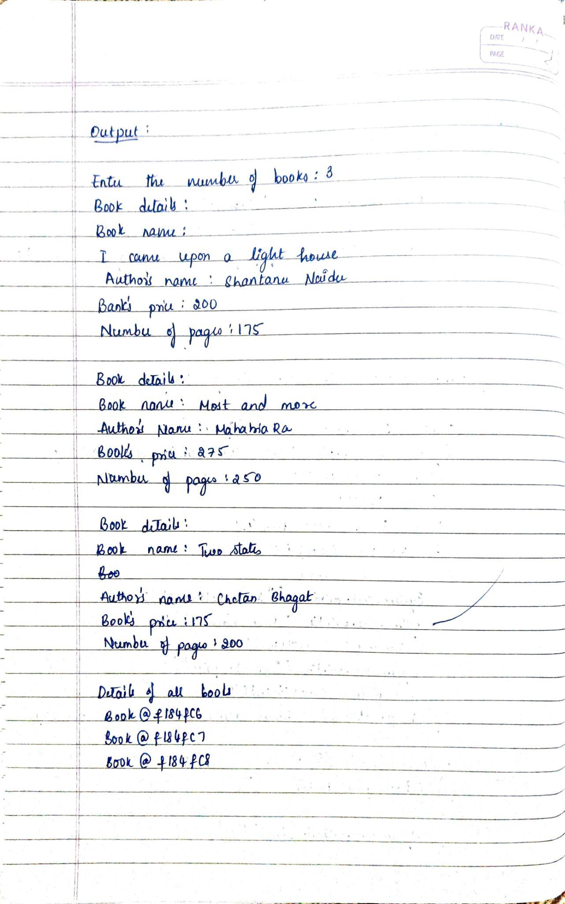

Code:

import java.util.Scanner;

class Book

{

private String name;

private String author;

private int price;

private int numpages;

public Book(String name, String author, int price, int numpages)

{

this.name=name;

this.author=author;

this.price=price;

this.numpages=numpages;

}

public String getname()

{

return name;

}

public String getauthor()

{

return author;

}

public int getprice()

{

return price;

}

public int getnumpages()

{

return numpages;

}

public void setname(String name)

{

this.name=name;

}

public void setauthor(String author)

{

this.author=author;

}

public void setprice(int price)

{

this.price=price;

}

public void setnumpages(int numpages)

{

this.numpages=numpages;

}

public String tostring()

{

String name, author, price, numPages;

name = "Book name: " + this.name + "\n";

author = "Author name: " + this.author + "\n";

price = "Price: " + this.price + "\n";

numPages = "Number of pages: " + this.numpages + "\n";

return name + author + price + numpages;

}

}

public class bookset

{

public static void main(String []args)

{

System.out.println("Name:Shreya");

System.out.println("USN:1BM23IC061");

Scanner sc=new Scanner(System.in);

System.out.println("Enter the number of books:");

int n=sc.nextInt();

sc.nextLine();

Book[] books=new Book[n];

for(int i=0;i<n; i++)

{

System.out.println("Book details:");

System.out.println("Book name:");

String name=sc.nextLine();

System.out.println("Authors name:");

String author=sc.nextLine();

System.out.println("Book price:");

int price=sc.nextInt();

System.out.println("Number of pages:");

int numpages=sc.nextInt();

books[i]=new Book (name,author,price,numpages);

}

System.out.println("Details of all books:");

for(Book book:books)

{

System.out.println(book);

}}

}

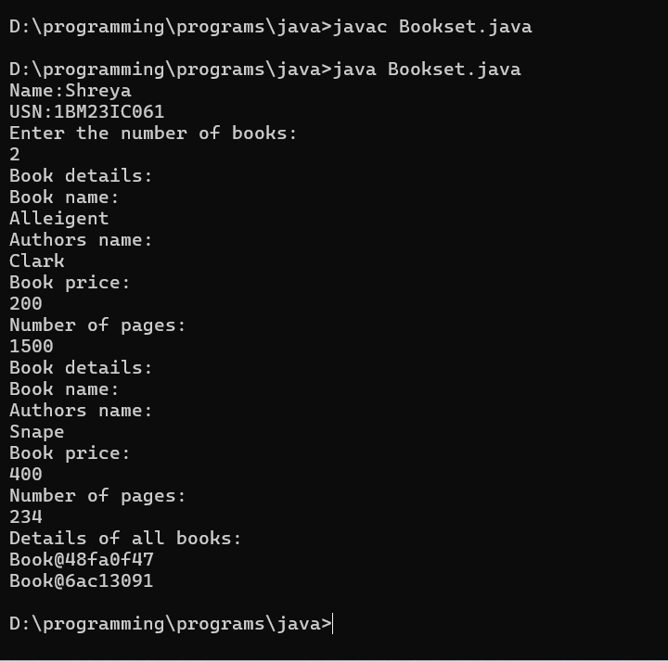

**Program 4**

Develop a Java program to create an abstract class named Shape that contains two integers and an empty method named printArea( ). Provide three classes named Rectangle, Triangle and Circle such

that each one of the classes extends the class Shape. Each one of the classes contain only the method printArea( ) that prints the area of the given shape.

Algorithm: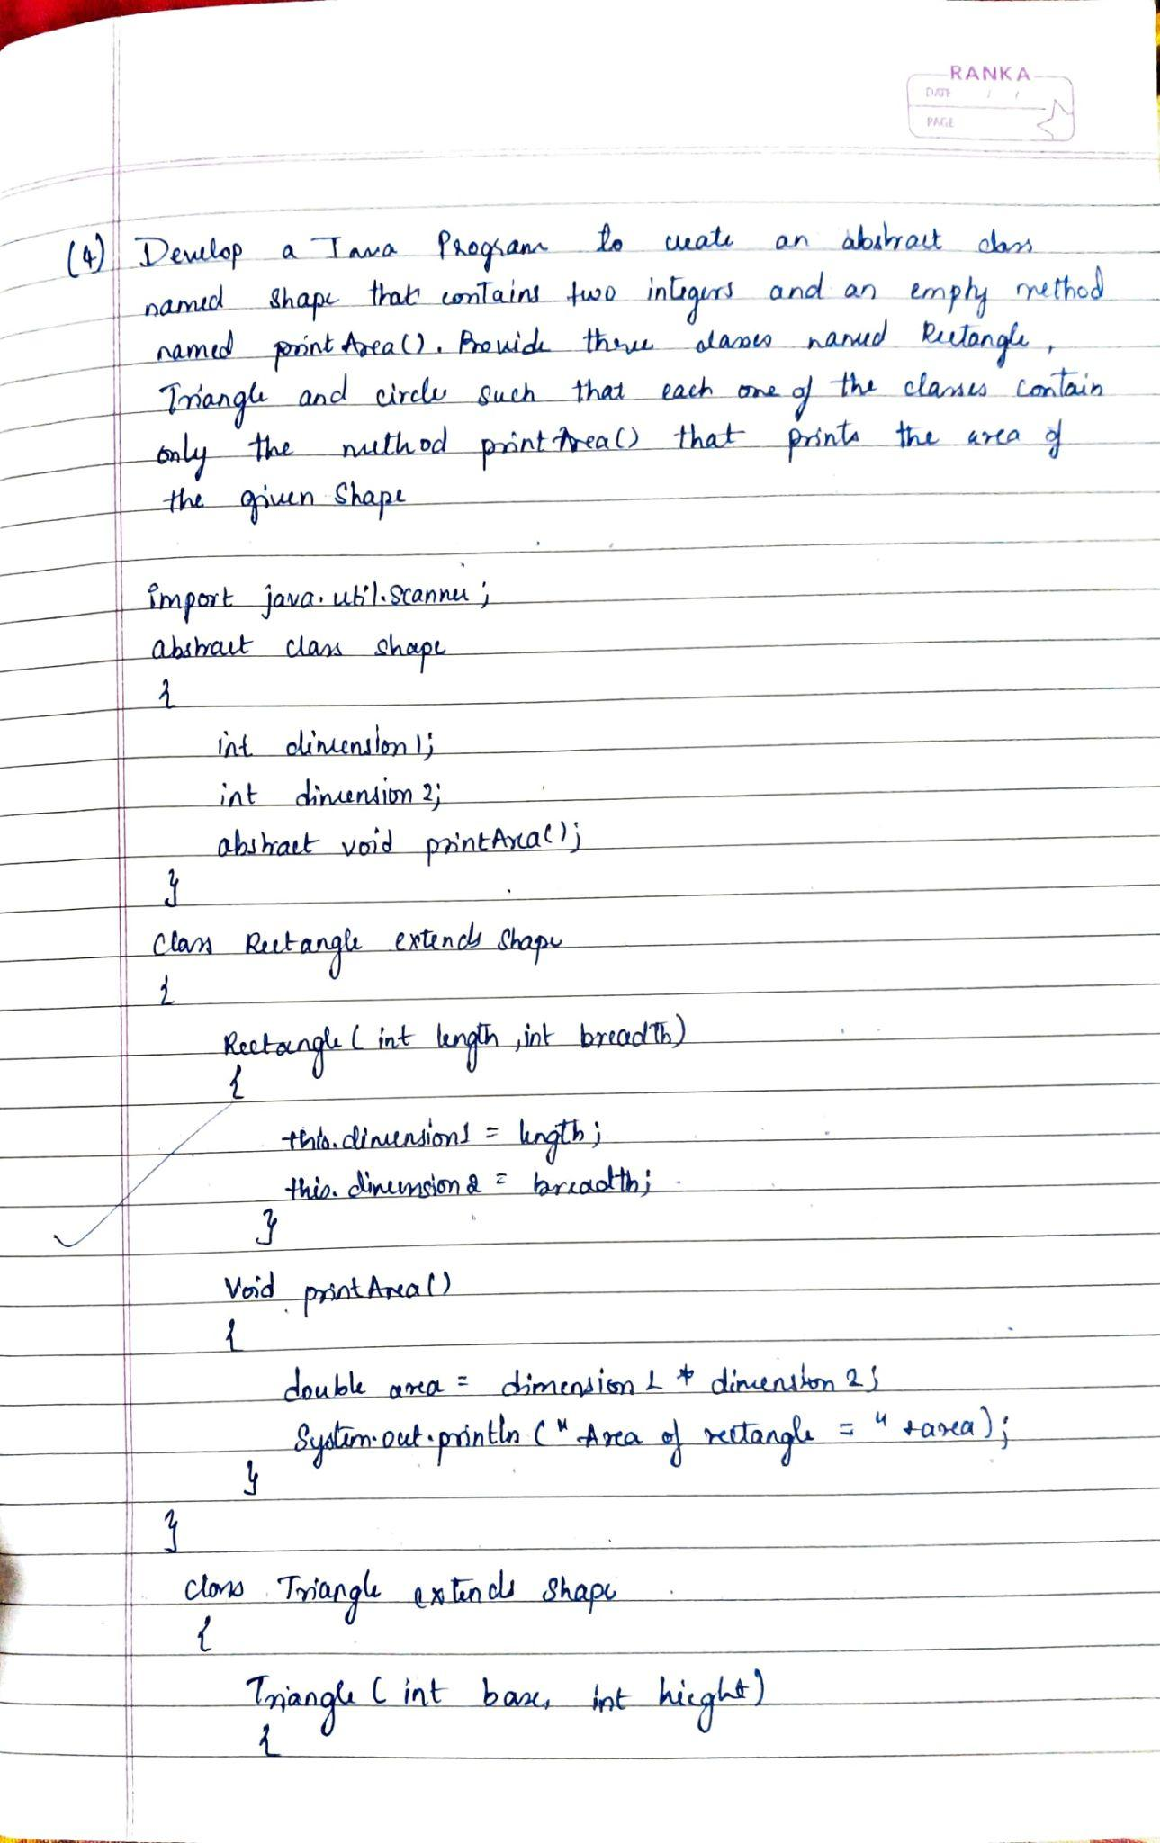

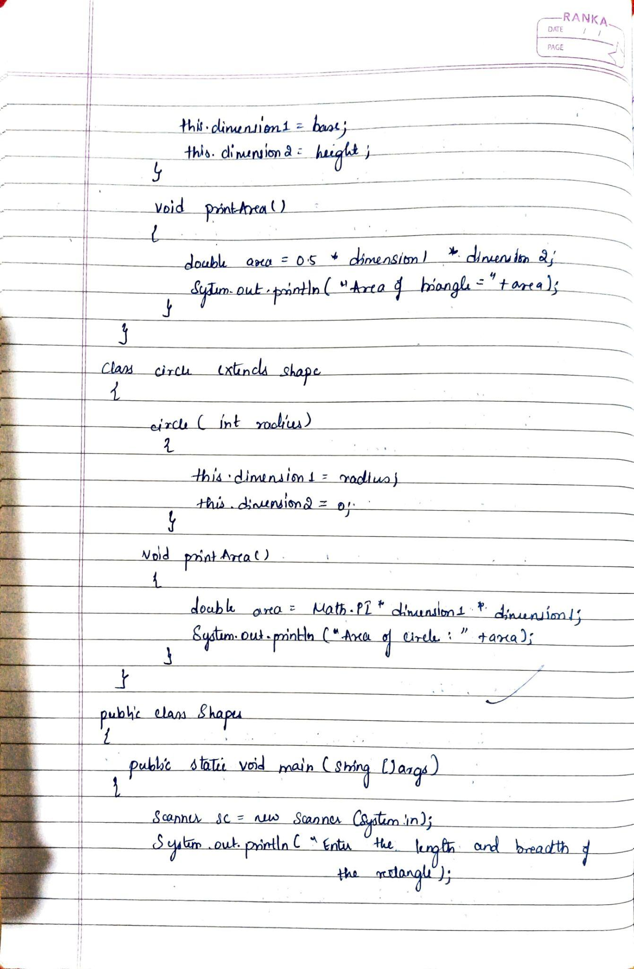

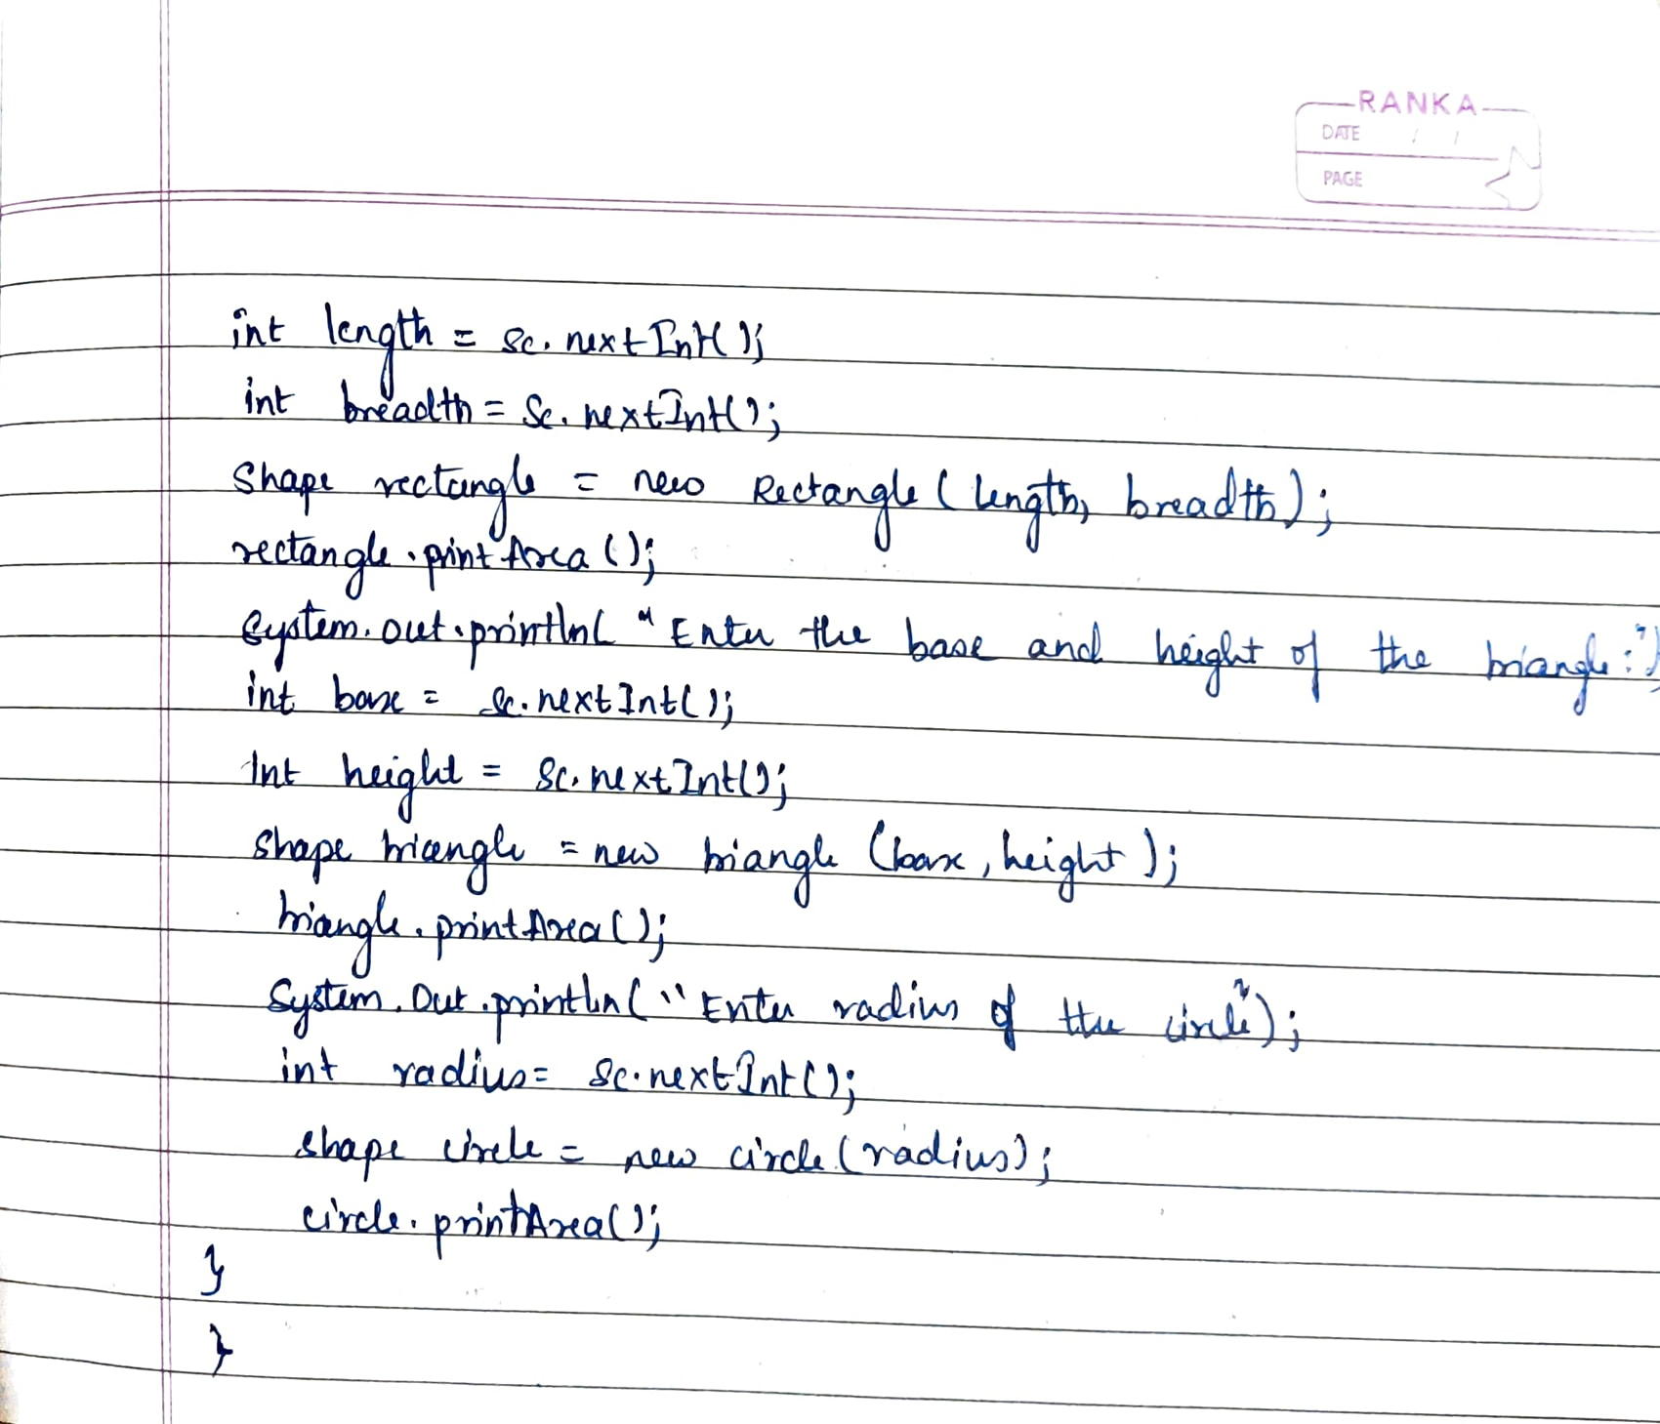

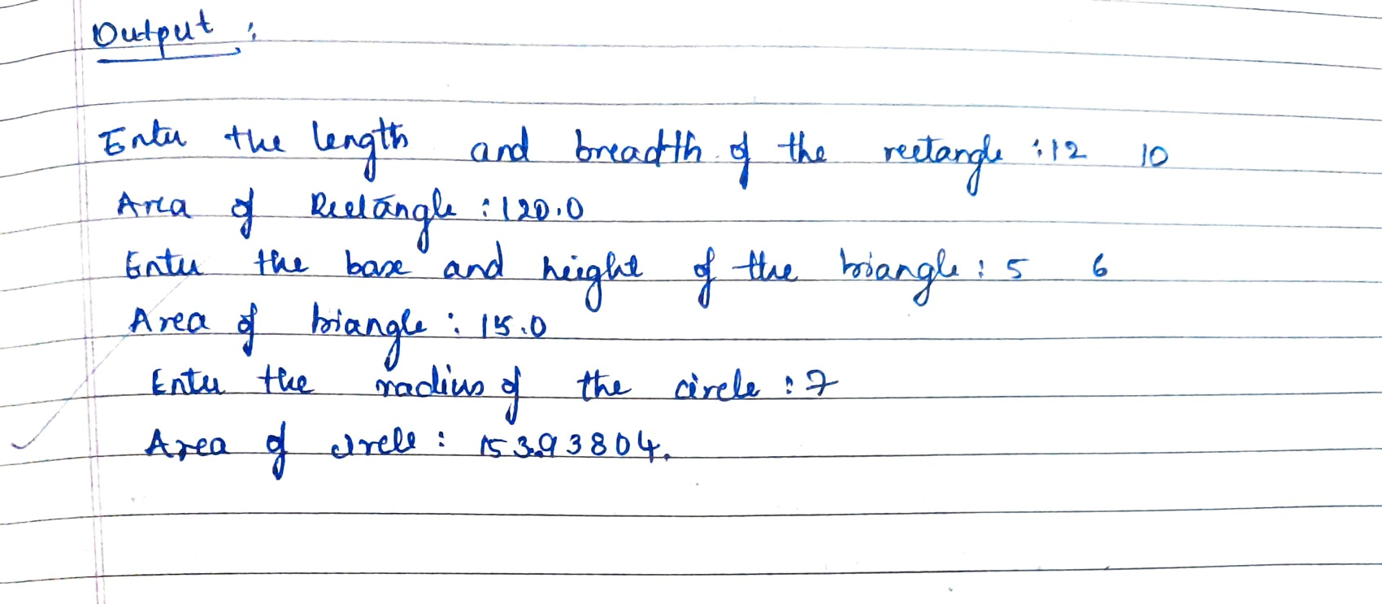

Code:

import java.util.Scanner;

abstract class Shape

{

int dimension1;

int dimension2;

abstract void printArea();

}

class Rectangle extends Shape

{

Rectangle(int length, int breadth)

{

this.dimension1 = length;

this.dimension2 = breadth;

}

void printArea()

{

double area = dimension1 * dimension2;

System.out.println("Area of Rectangle: " + area);

}

}

class Triangle extends Shape

{

Triangle(int base, int height)

{

this.dimension1 = base;

this.dimension2 = height;

}

void printArea()

{

double area = 0.5 * dimension1 * dimension2;

System.out.println("Area of Triangle: " + area);

}

}

class Circle extends Shape

{

Circle(int radius)

{

this.dimension1 = radius;

this.dimension2 = 0;

}

void printArea()

{

double area = Math.PI * dimension1 * dimension1;

System.out.println("Area of Circle: " + area);

}

}

public class shapes

{

public static void main(String[] args)

{

Scanner sc = new Scanner(System.in);

System.out.print("Enter the length and breadth of the rectangle: ");

int length = sc.nextInt();

int breadth = sc.nextInt();

Shape rectangle = new Rectangle(length, breadth);

rectangle.printArea();

System.out.print("Enter the base and height of the triangle: ");

int base = sc.nextInt();

int height = sc.nextInt();

Shape triangle = new Triangle(base, height);

triangle.printArea();

System.out.print("Enter the radius of the circle: ");

int radius = sc.nextInt();

Shape circle = new Circle(radius);

circle.printArea();

}

}

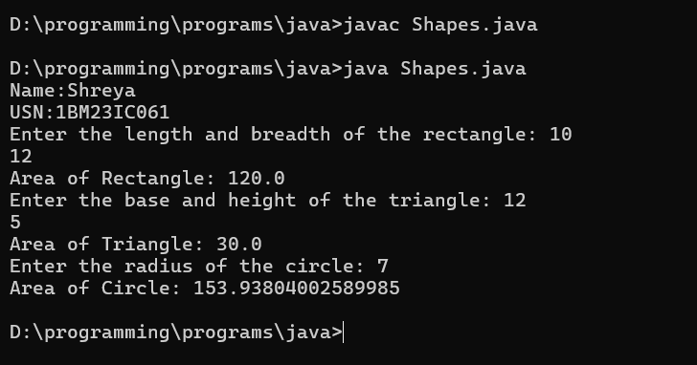

**Program 5**

Develop a Java program to create a class Bank that maintains two kinds of account for its customers, one called savings account and the other current account. The savings account provides compound interest and withdrawal facilities but no cheque book facility. The current account provides cheque book facility but no interest. Current account holders should also maintain a minimum balance and if the balance falls below this level, a service charge is imposed.

Create a class Account that stores customer name, account number and type of account. From this

derive the classes Cur-acct and Sav-acct to make them more specific to their requirements. Include

the necessary methods in order to achieve the following tasks:

a)Accept deposit from customer and update the balance.

b)Display the balance.

c)Compute and deposit interest

d)Permit withdrawal and update the balance

e) Check for the minimum balance, impose penalty if necessary and update the balance.

Algorithm:

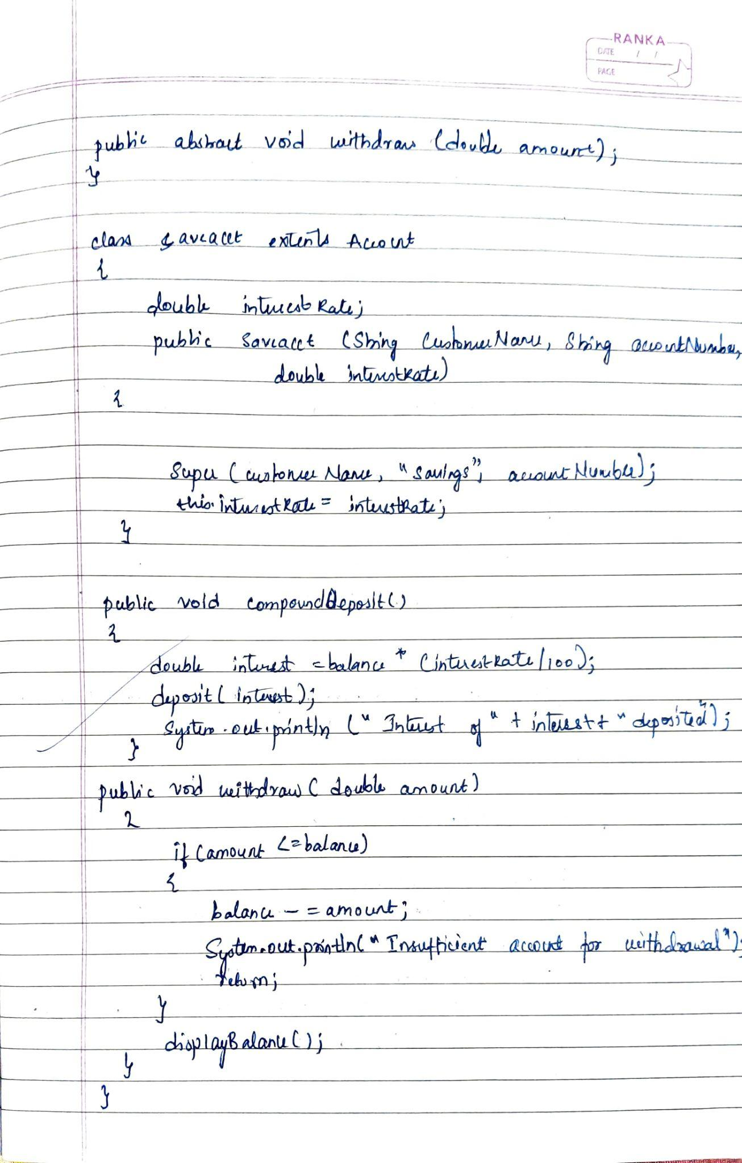

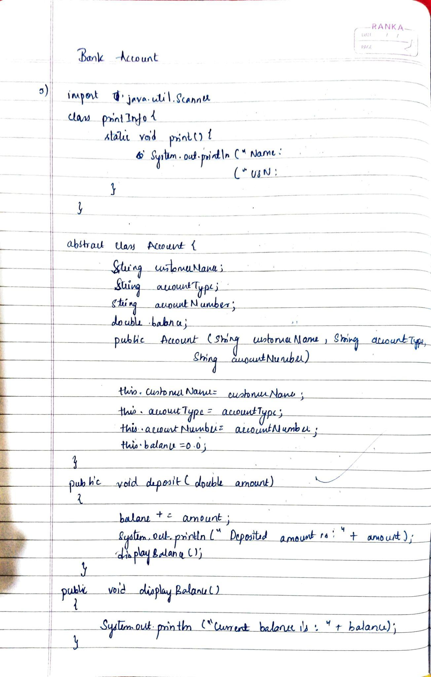

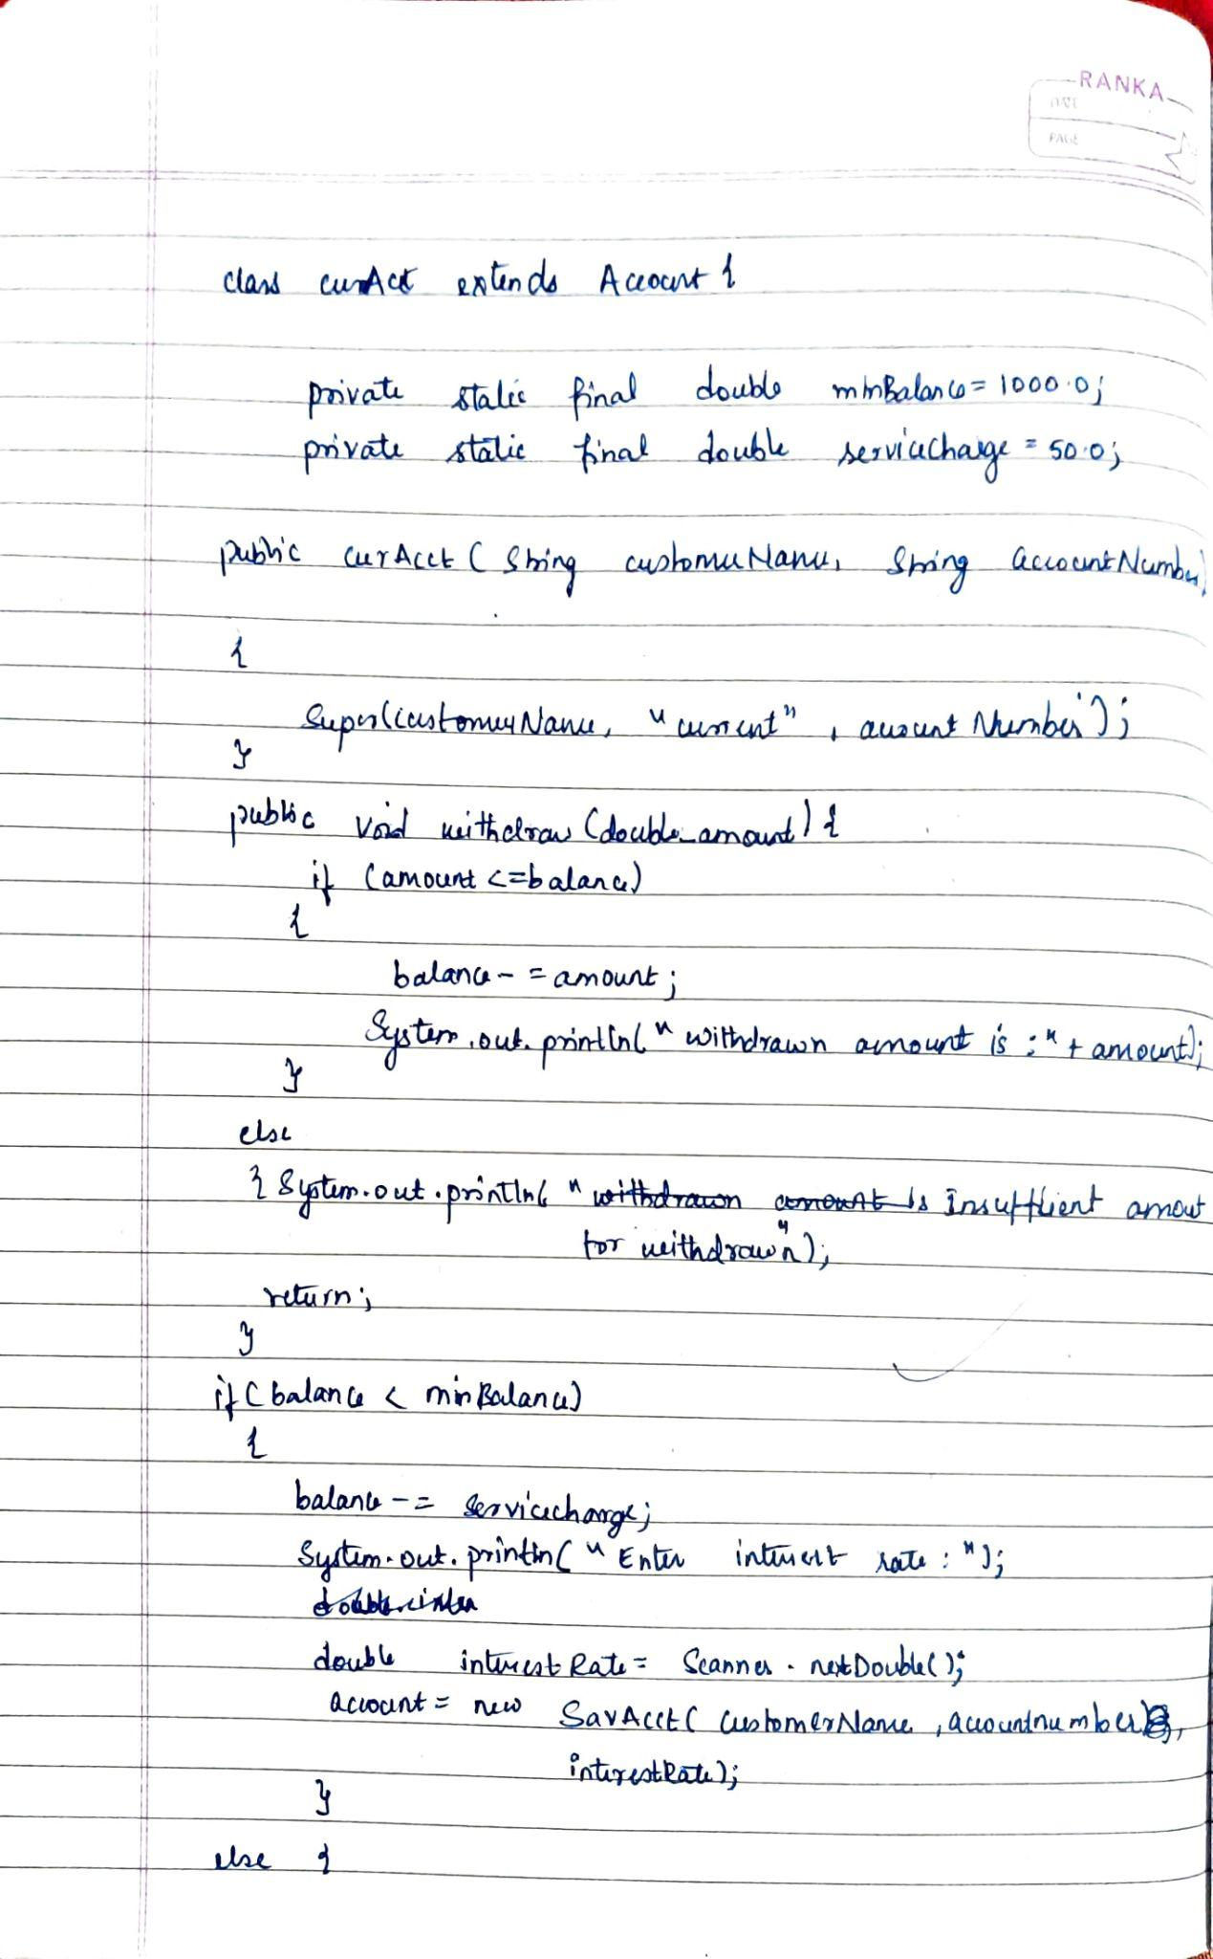

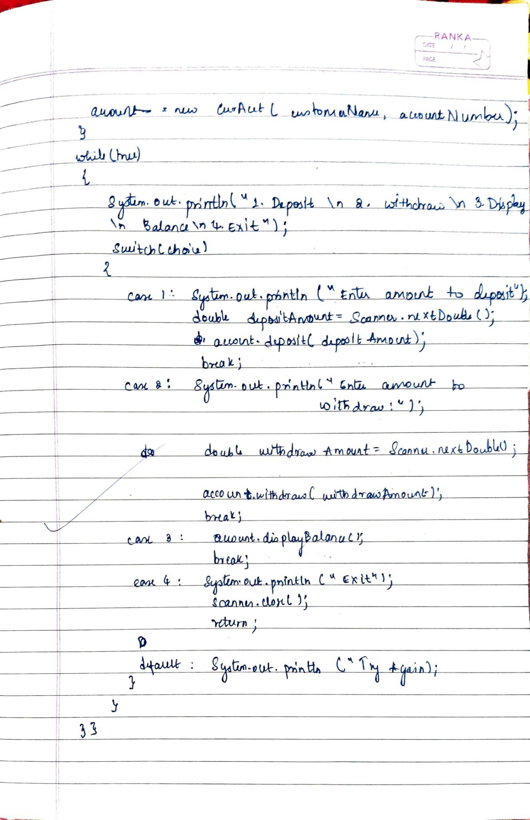

Code:

import java.util.Scanner;

// Main class with switch cases

public class Bank {

public static void main(String[] args) {

Scanner scanner = new Scanner(System.in);

PrintInfo.print();

System.out.println("Select Account Type:");

System.out.println("1. Savings Account");

System.out.println("2. Current Account");

int choice = scanner.nextInt();

scanner.nextLine(); // Consume the newline

Account account = null;

if (choice == 1) {

System.out.println("Enter Customer Name:");

String name = scanner.nextLine();

System.out.println("Enter Account Number:");

String accNum = scanner.nextLine();

System.out.println("Enter Interest Rate:");

double rate = scanner.nextDouble();

account = new SavAcct(name, accNum, rate);

} else if (choice == 2) {

System.out.println("Enter Customer Name:");

String name = scanner.nextLine();

System.out.println("Enter Account Number:");

String accNum = scanner.nextLine();

account = new CurAcct(name, accNum);

} else {

System.out.println("Invalid choice!");

System.exit(0);

}

int option;

do {

System.out.println("\nSelect an option:");

System.out.println("1. Deposit");

System.out.println("2. Withdraw");

if (account instanceof SavAcct) {

System.out.println("3. Compound Interest");

}

System.out.println("4. Display Balance");

System.out.println("5. Exit");

option = scanner.nextInt();

switch (option) {

case 1:

System.out.println("Enter deposit amount:");

double depositAmount = scanner.nextDouble();

account.deposit(depositAmount);

break;

case 2:

System.out.println("Enter withdrawal amount:");

double withdrawAmount = scanner.nextDouble();

account.withdraw(withdrawAmount);

break;

case 3:

if (account instanceof SavAcct) {

((SavAcct) account).compoundDeposit();

} else {

System.out.println("Invalid option for Current Account.");

}

break;

case 4:

account.displayBalance();

break;

case 5:

System.out.println("Thank you for using the bank system!");

break;

default:

System.out.println("Invalid choice! Please try again.");

}

} while (option != 5);

scanner.close();

}

}

// Utility class for printing information

class PrintInfo {

static void print() {

System.out.println("C Name:Shreya J G \n USN:1BM23IC061\n");

}

}

// Abstract Account class

abstract class Account {

String customerName;

String accountType;

String accountNumber;

double balance;

public Account(String customerName, String accountType, String accountNumber) {

this.customerName = customerName;

this.accountType = accountType;

this.accountNumber = accountNumber;

this.balance = 0.0;

}

public void deposit(double amount) {

balance += amount;

System.out.println("Deposited amount is: " + amount);

displayBalance();

}

public void displayBalance() {

System.out.println("Current balance is: " + balance);

}

public abstract void withdraw(double amount);

}

// Savings Account class

class SavAcct extends Account {

double interestRate;

public SavAcct(String customerName, String accountNumber, double interestRate) {

super(customerName, "Savings", accountNumber);

this.interestRate = interestRate;

}

public void compoundDeposit() {

double interest = balance * (interestRate / 100);

deposit(interest);

System.out.println("Interest of " + interest + " deposited.");

}

public void withdraw(double amount) {

if (amount <= balance) {

balance -= amount;

System.out.println("Withdrawn amount is: " + amount);

} else {

System.out.println("Insufficient balance for withdrawal.");

}

displayBalance();

}

}

// Current Account class

class CurAcct extends Account {

private static final double minBalance = 1000.0;

private static final double serviceCharge = 50.0;

public CurAcct(String customerName, String accountNumber) {

super(customerName, "Current", accountNumber);

}

public void withdraw(double amount) {

if (amount <= balance) {

balance -= amount;

System.out.println("Withdrawn amount is: " + amount);

} else {

System.out.println("Insufficient amount for withdrawal.");

return;

}

if (balance < minBalance) {

balance -= serviceCharge;

System.out.println("Balance below minimum! Service charge of " + serviceCharge + " applied.");

}

displayBalance();

}

}

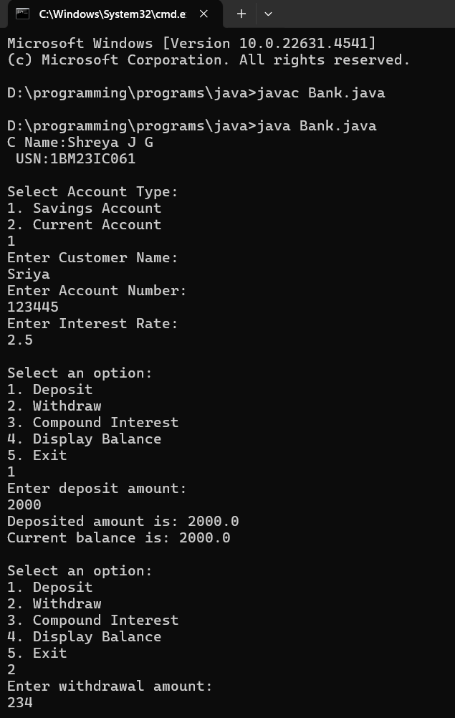

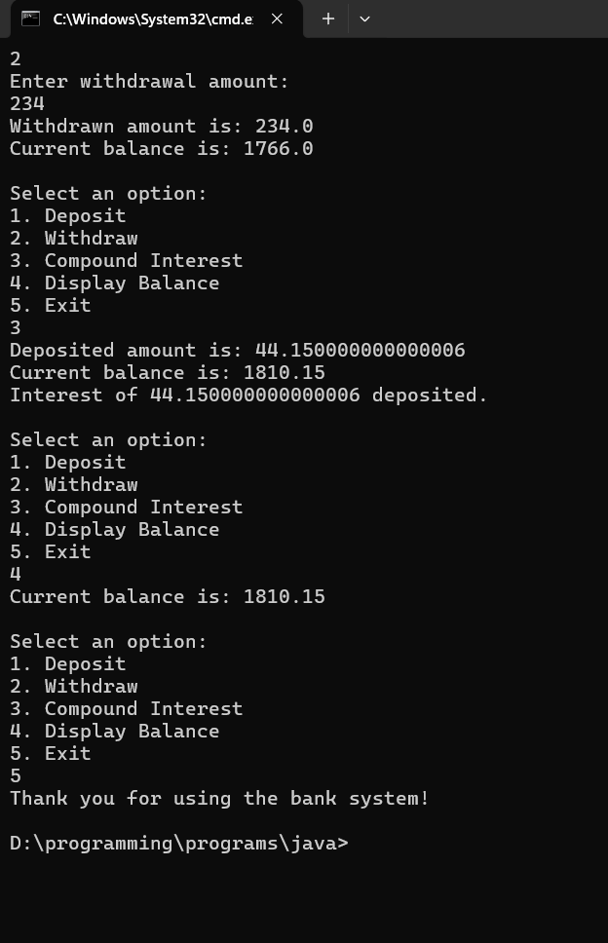

**Program 6**

Create a package CIE which has two classes- Student and Internals. The class Student has members like usn, name, sem. The class Internals derived from Student has an array that stores the internal marks scored in five courses of the current semester of the student. Create another package SEE which has the class External which is a derived class of Student. This class has an array that stores the SEE marks scored in five courses of the current semester of the student. Import the two packages in a file that declares the final marks of n students in all five courses.

Algorithm:

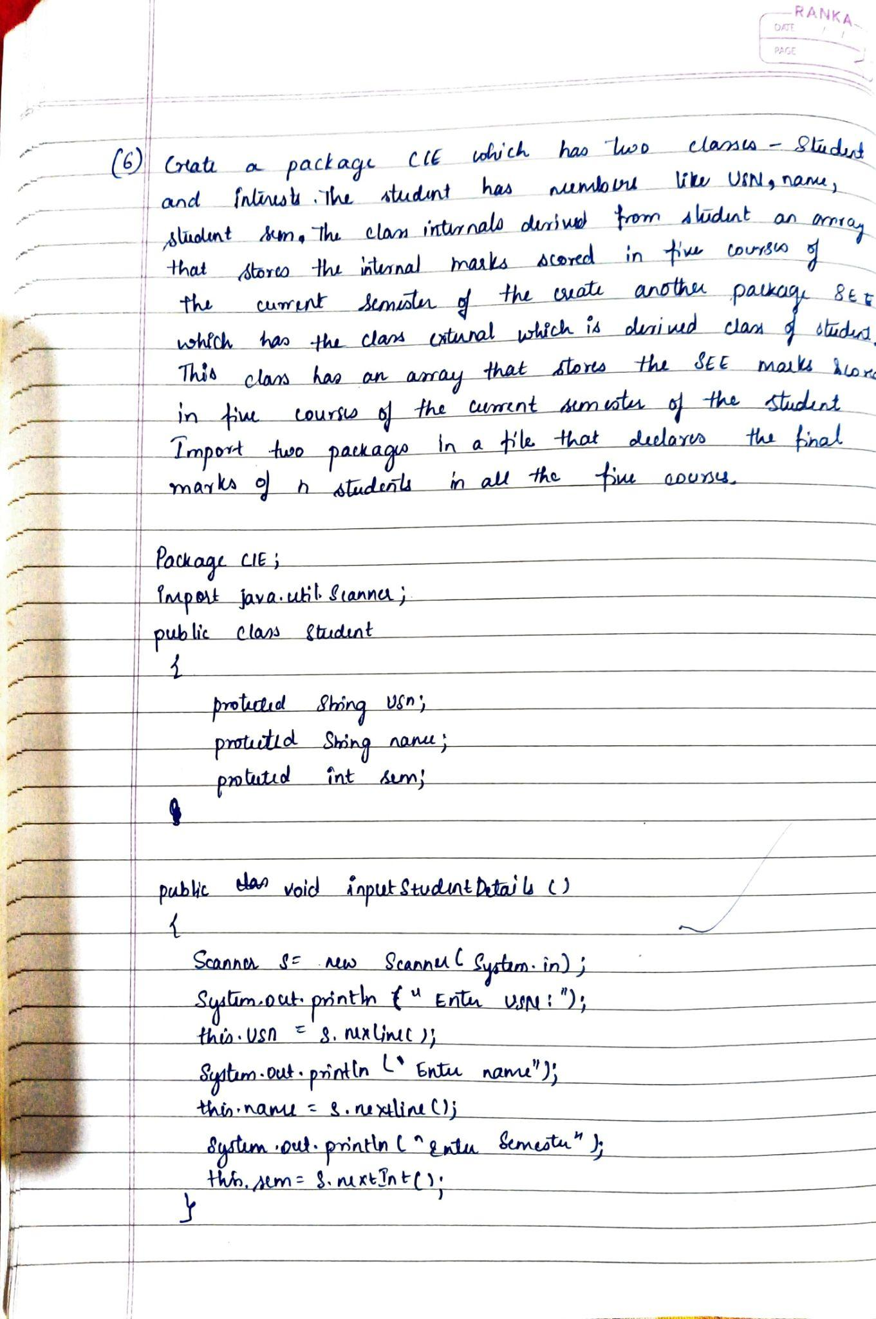

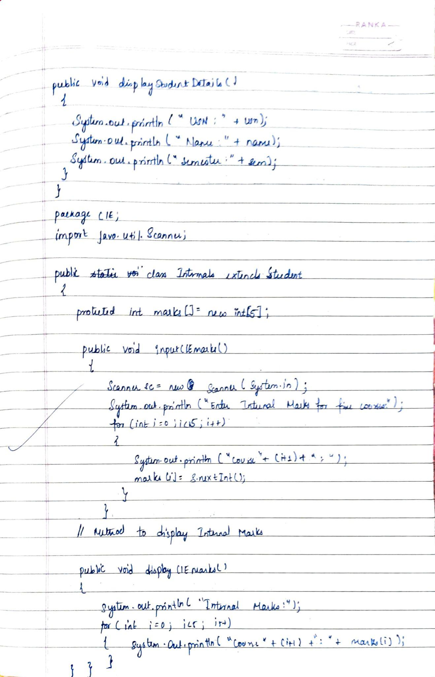

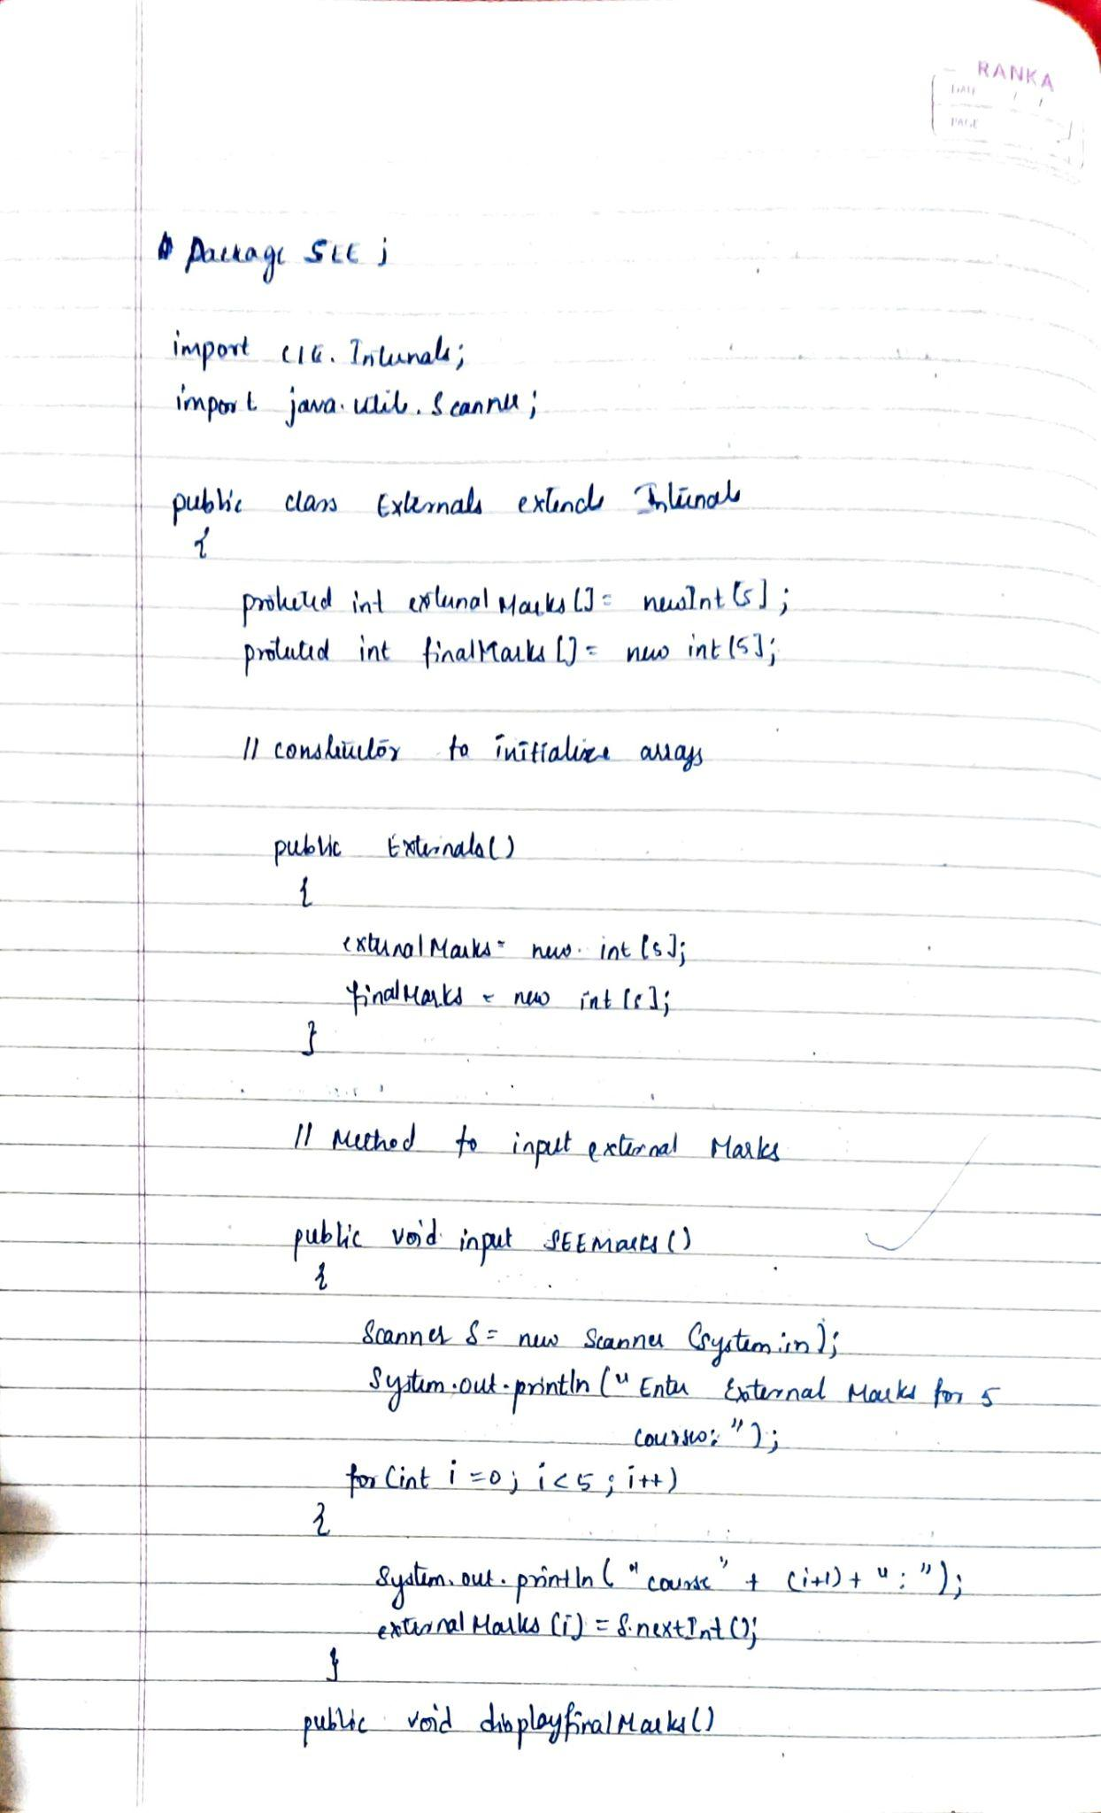

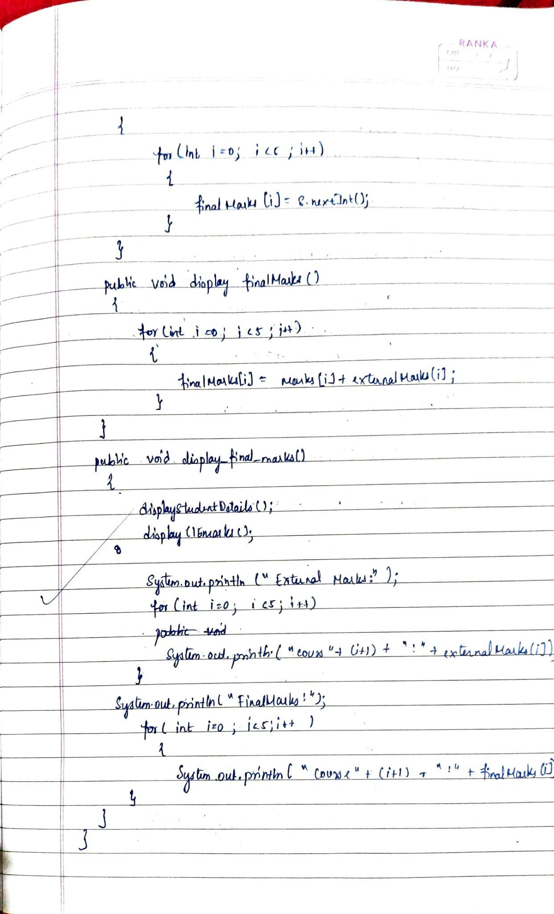

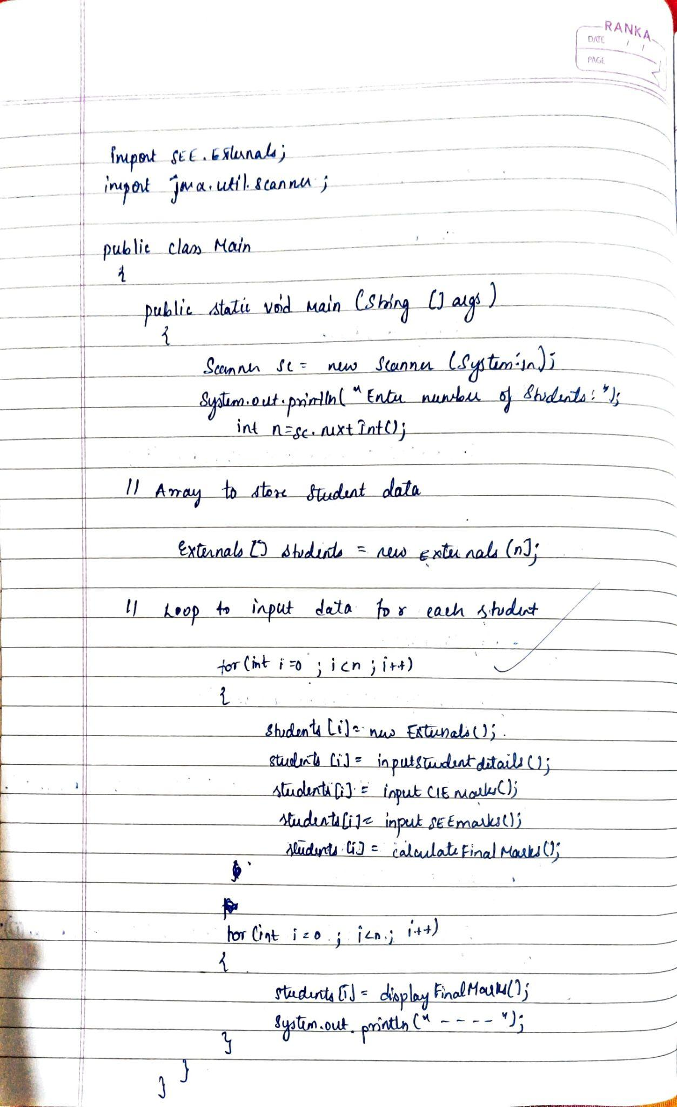

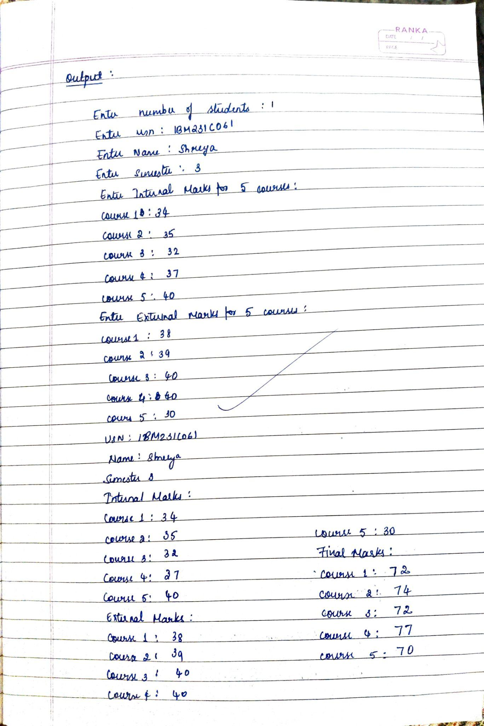

Code:

// File: SEE/Externals.java

package SEE;

import CIE.Internals; // Import Internals class from CIE package

import java.util.Scanner;

public class Externals extends Internals {

protected int externalMarks[] = new int[5]; // Array to store external marks for 5 courses

protected int finalMarks[] = new int[5]; // Array to store final marks (sum of internal and external)

// Constructor to initialize arrays

public Externals() {

externalMarks = new int[5];

finalMarks = new int[5];

}

// Method to input external marks

public void inputSEEmarks() {

Scanner s = new Scanner(System.in);

System.out.println("Enter External Marks for 5 courses: ");

for (int i = 0; i < 5; i++) {

System.out.print("Course " + (i + 1) + ": ");

externalMarks[i] = s.nextInt();

}

}

// Method to calculate final marks (sum of internal and external)

public void calculateFinalMarks() {

for (int i = 0; i < 5; i++) {

finalMarks[i] = marks[i] + externalMarks[i]; // Internal + External

}

}

// Method to display final marks

public void displayFinalMarks() {

displayStudentDetails(); // Display student details (from parent class)

displayCIEmarks(); // Display internal marks (from parent class)

System.out.println("External Marks: ");

for (int i = 0; i < 5; i++) {

System.out.println("Course " + (i + 1) + ": " + externalMarks[i]);

}

System.out.println("Final Marks: ");

for (int i = 0; i < 5; i++) {

System.out.println("Course " + (i + 1) + ": " + finalMarks[i]);

}

}

}

// File: CIE/Internals.java

package CIE;

import java.util.Scanner;

public class Internals extends Student {

protected int marks[] = new int[5]; // Array to store internal marks for 5 courses

// Method to input internal marks

public void inputCIEmarks() {

Scanner s = new Scanner(System.in);

System.out.println("Enter Internal Marks for 5 courses: ");

for (int i = 0; i < 5; i++) {

System.out.print("Course " + (i + 1) + ": ");

marks[i] = s.nextInt();

}

}

// Method to display internal marks

public void displayCIEmarks() {

System.out.println("Internal Marks: ");

for (int i = 0; i < 5; i++) {

System.out.println("Course " + (i + 1) + ": " + marks[i]);

}

}

}

// File: CIE/Student.java

package CIE;

import java.util.Scanner;

public class Students {

protected String usn;

protected String name;

protected int sem;

// Method to input student details

public void inputStudentDetails() {

Scanner s = new Scanner(System.in);

System.out.print("Enter USN: ");

this.usn = s.nextLine();

System.out.print("Enter Name: ");

this.name = s.nextLine();

System.out.print("Enter Semester: ");

this.sem = s.nextInt();

}

// Method to display student details

public void displayStudentDetails() {

System.out.println("USN: " + usn);

System.out.println("Name: " + name);

System.out.println("Semester: " + sem);

}

}

// File: Main.java

import SEE.Externals; // Import Externals class from SEE package

import java.util.Scanner;

public class Packages {

public static void main(String[] args) {

Scanner sc = new Scanner(System.in);

System.out.print("Enter number of students: ");

int n = sc.nextInt();

// Array to store student data

Externals[] students = new Externals[n];

// Loop to input data for each student

for (int i = 0; i < n; i++) {

students[i] = new Externals();

// Input student details, internal marks, and external marks

students[i].inputStudentDetails();

students[i].inputCIEmarks();

students[i].inputSEEmarks();

students[i].calculateFinalMarks();

}

// Display the final results of all students

for (int i = 0; i < n; i++) {

students[i].displayFinalMarks();

System.out.println("--------------------------------------------");

}

}

}

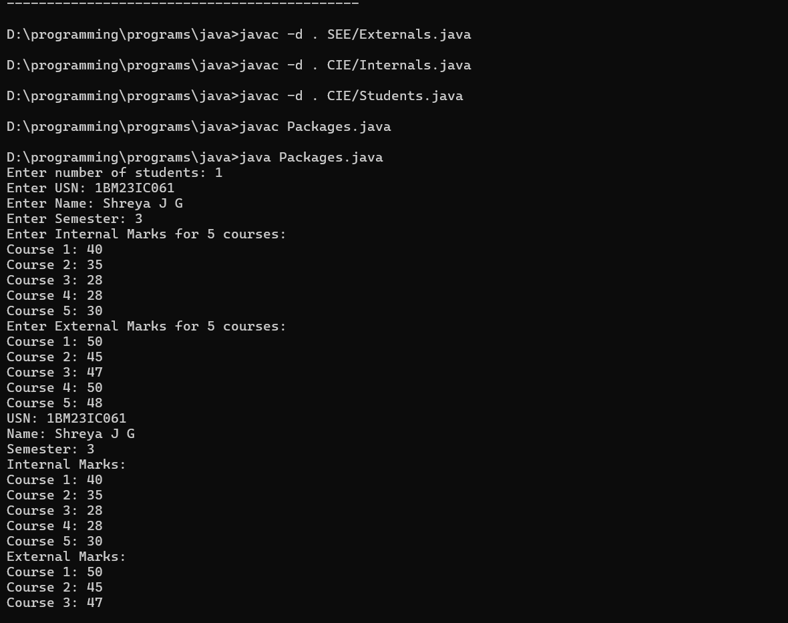

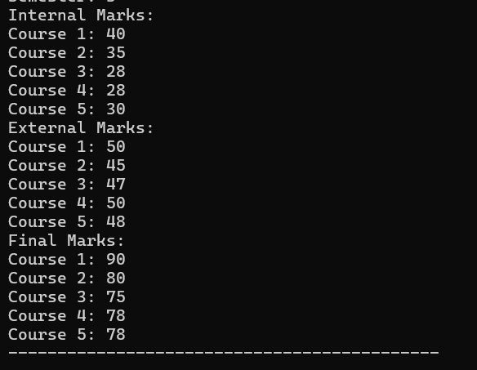

**Program 7**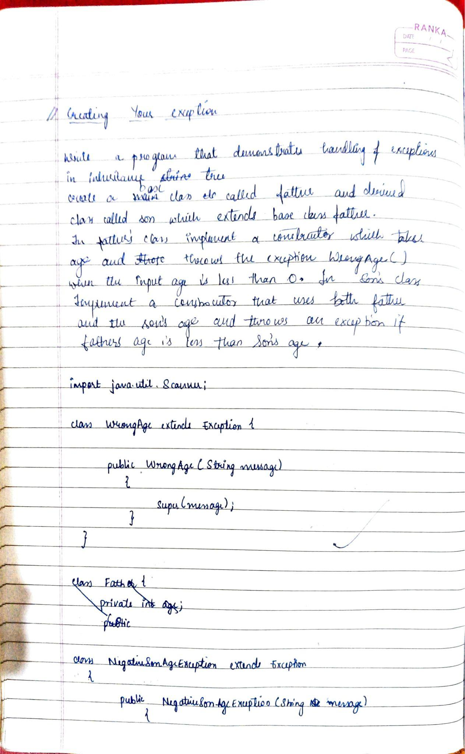

Algorithm:

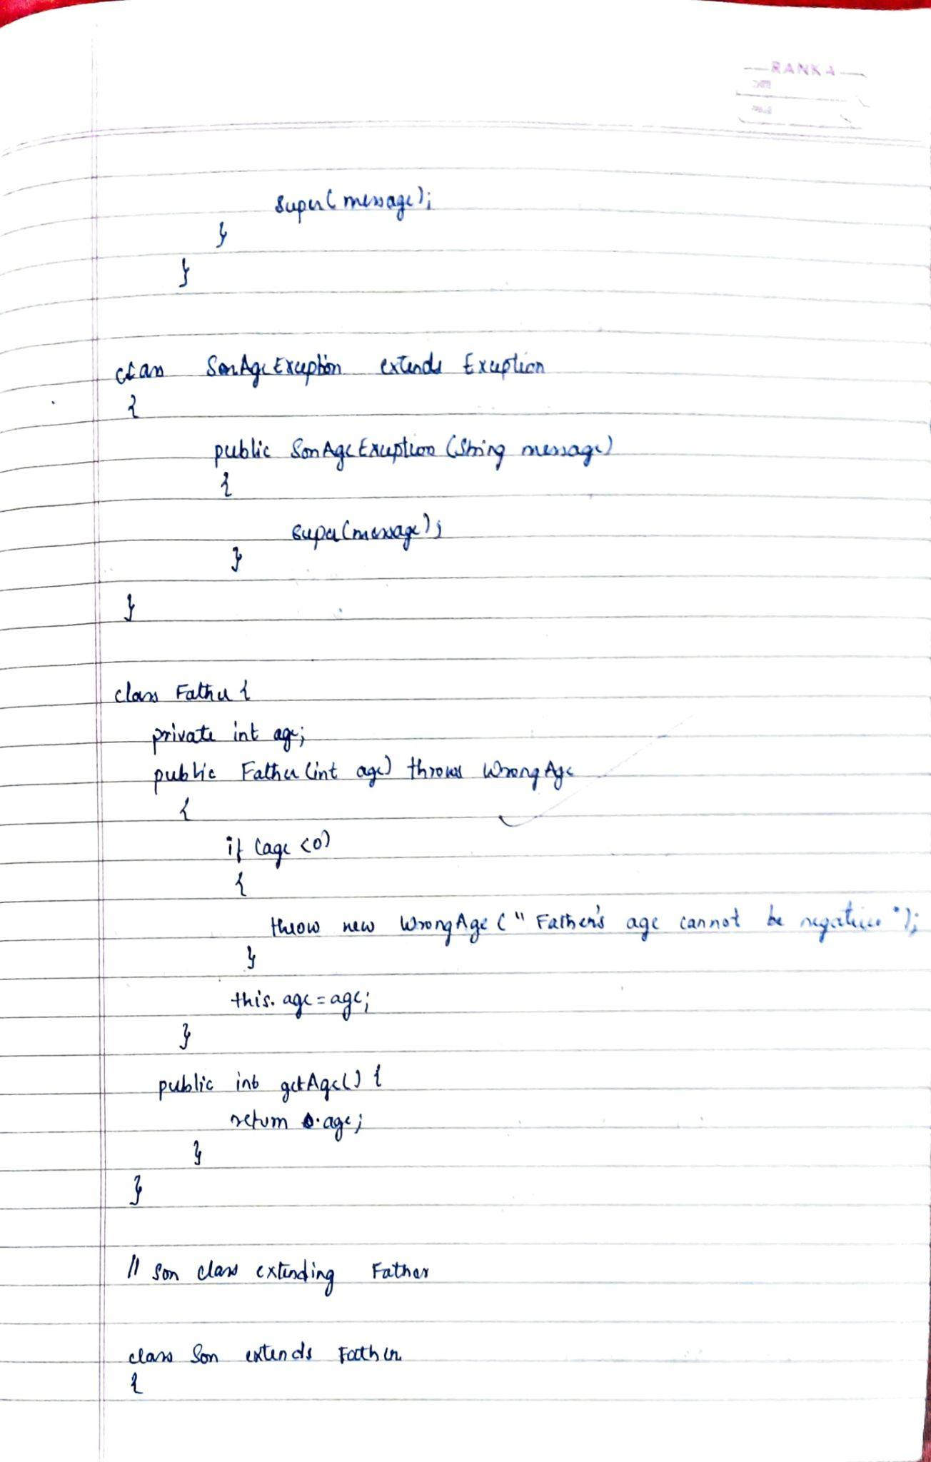

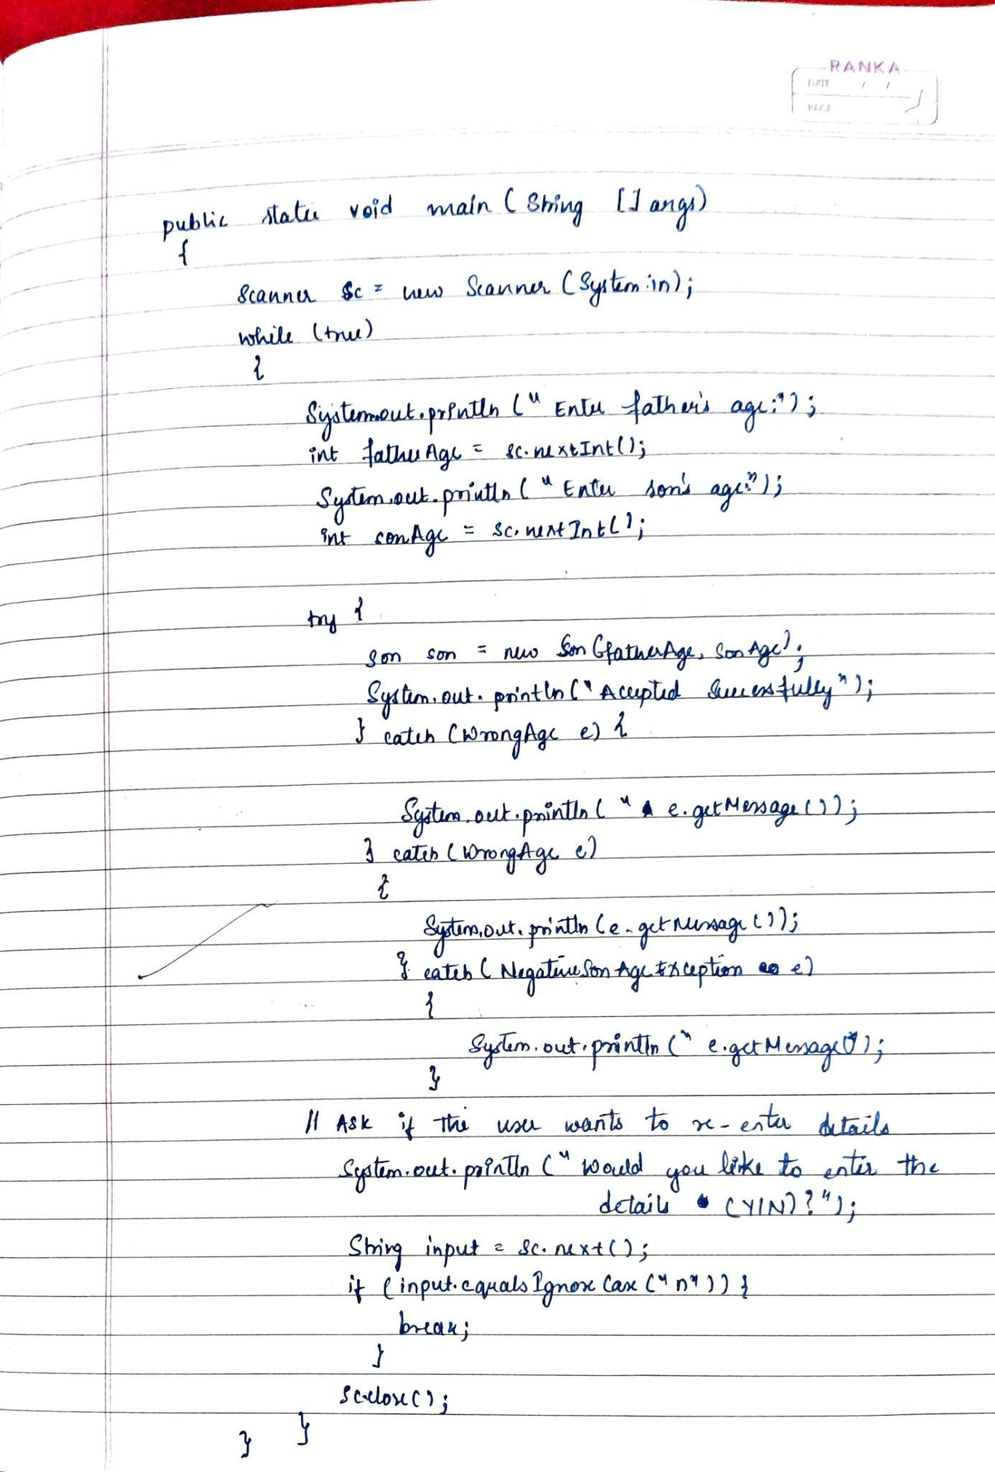

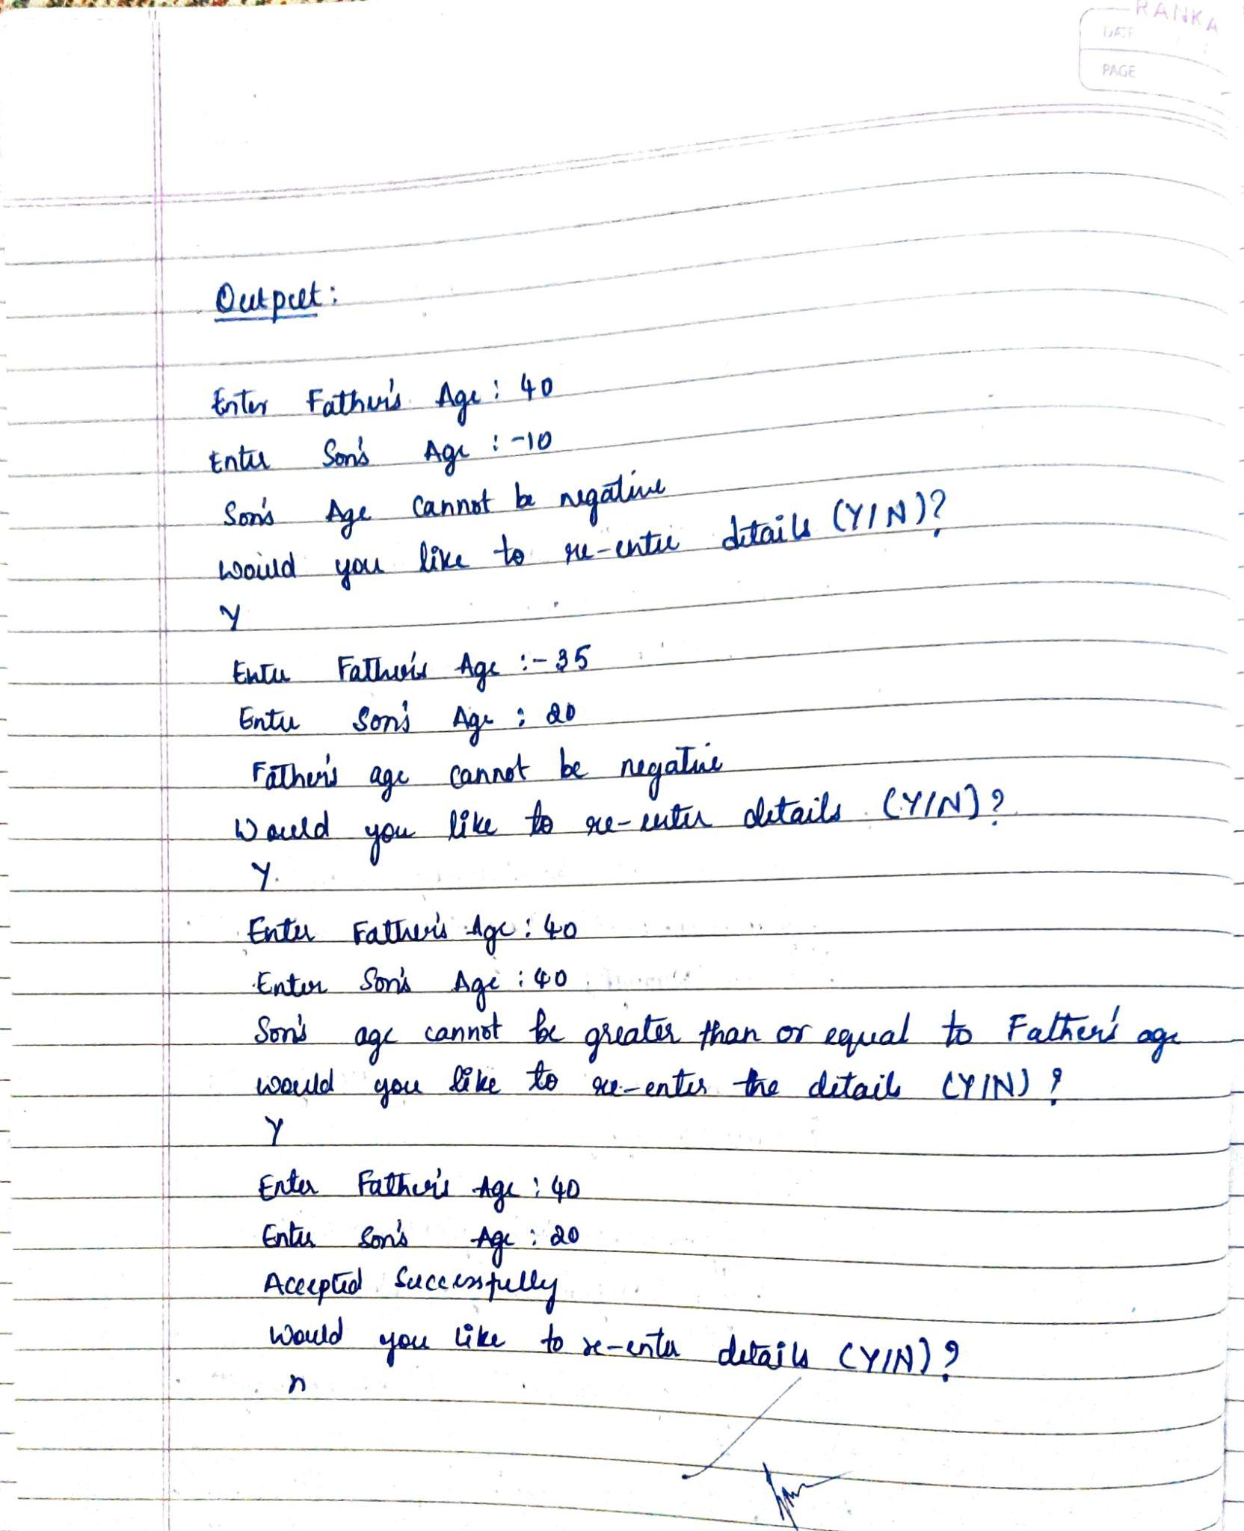

Code:

import java.util.Scanner;

class WrongAge extends Exception {

public WrongAge(String message) {

super(message);

}

}

class SonAgeException extends Exception {

public SonAgeException(String message) {

super(message);

}

}

class NegativeSonAgeException extends Exception {

public NegativeSonAgeException(String message) {

super(message);

}

}

class Father {

private int age;

public Father(int age) throws WrongAge {

if (age < 0) {

throw new WrongAge("Father's age cannot be negative");

}

this.age = age;

}

public int getAge() {

return age;

}

}

class Son extends Father {

private int sonAge;

public Son(int fatherAge, int sonAge) throws WrongAge, SonAgeException, NegativeSonAgeException {

super(fatherAge);

if (sonAge < 0) {

throw new NegativeSonAgeException("Son's age cannot be negative");

}

if (sonAge >= fatherAge) {

throw new SonAgeException("Son's age cannot be greater than or equal to father's age");

}

this.sonAge = sonAge;

}

public int getSonAge() {

return sonAge;

}

}

public class FatherSon {

public static void main(String[] args) {

System.out. println(“Name:Shreya”);

System.out. println(“USN:1BM23IC061”);

Scanner sc = new Scanner(System.in);

while (true) {

System.out.print("Enter Father's Age: ");

int fatherAge = sc.nextInt();

System.out.print("Enter Son's Age: ");

int sonAge = sc.nextInt();

try {

Son son = new Son(fatherAge, sonAge); // Create Son object

System.out.println("Accepted Successfully");

} catch (WrongAge e) {

System.out.println(e.getMessage());

} catch (SonAgeException e) {

System.out.println(e.getMessage());

} catch (NegativeSonAgeException e) {

System.out.println(e.getMessage());

}

// Ask if the user wants to re-enter details

System.out.println("Would you like to re-enter details (Y/n)?");

String input = sc.next();

if (input.equalsIgnoreCase("n")) {

break;

}

}

sc.close();

}

}

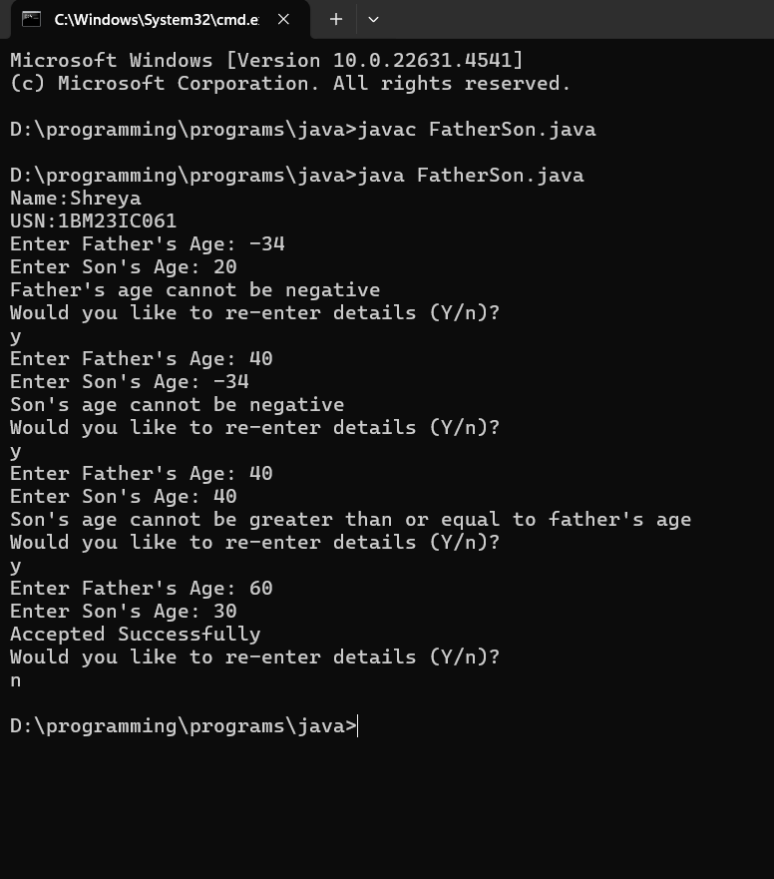

**Program 8**

Write a program which creates two threads, one thread displaying “BMS College of Engineering” once every ten seconds and another displaying “CSE” once very two seconds.

Algorithm:

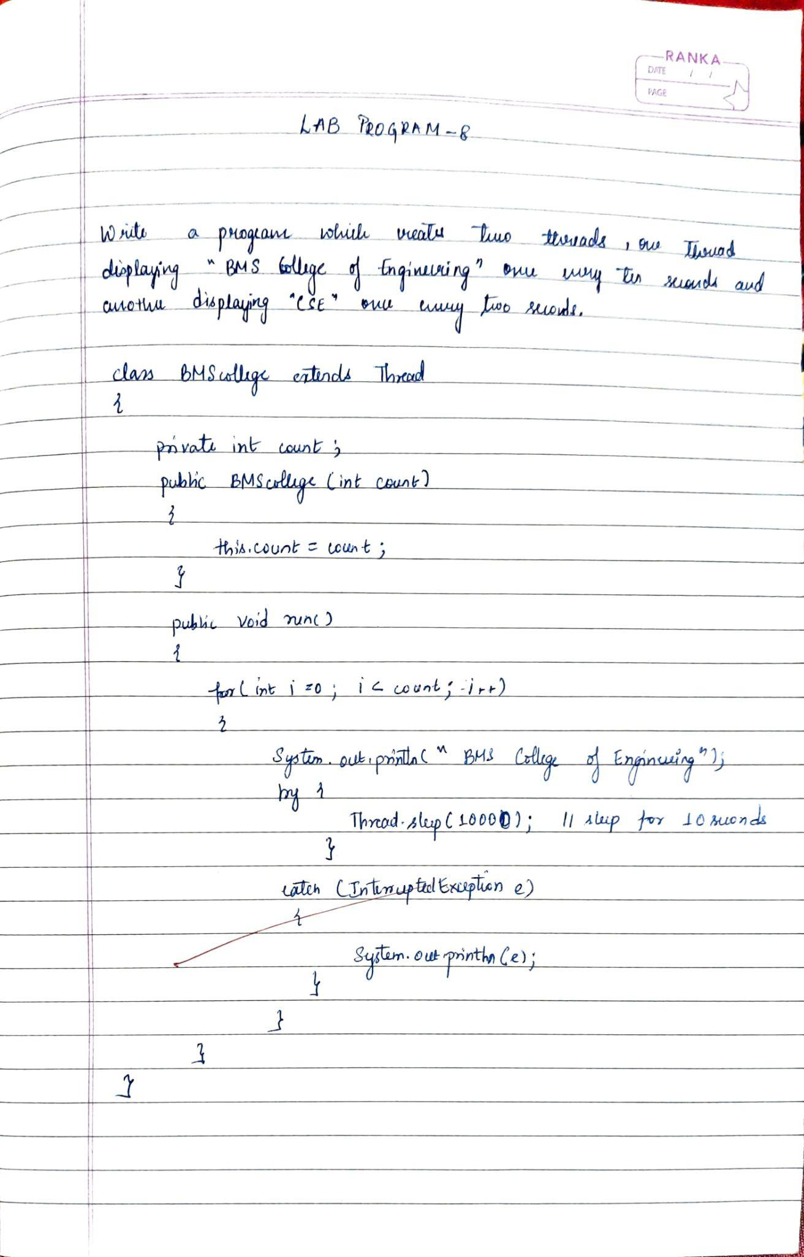

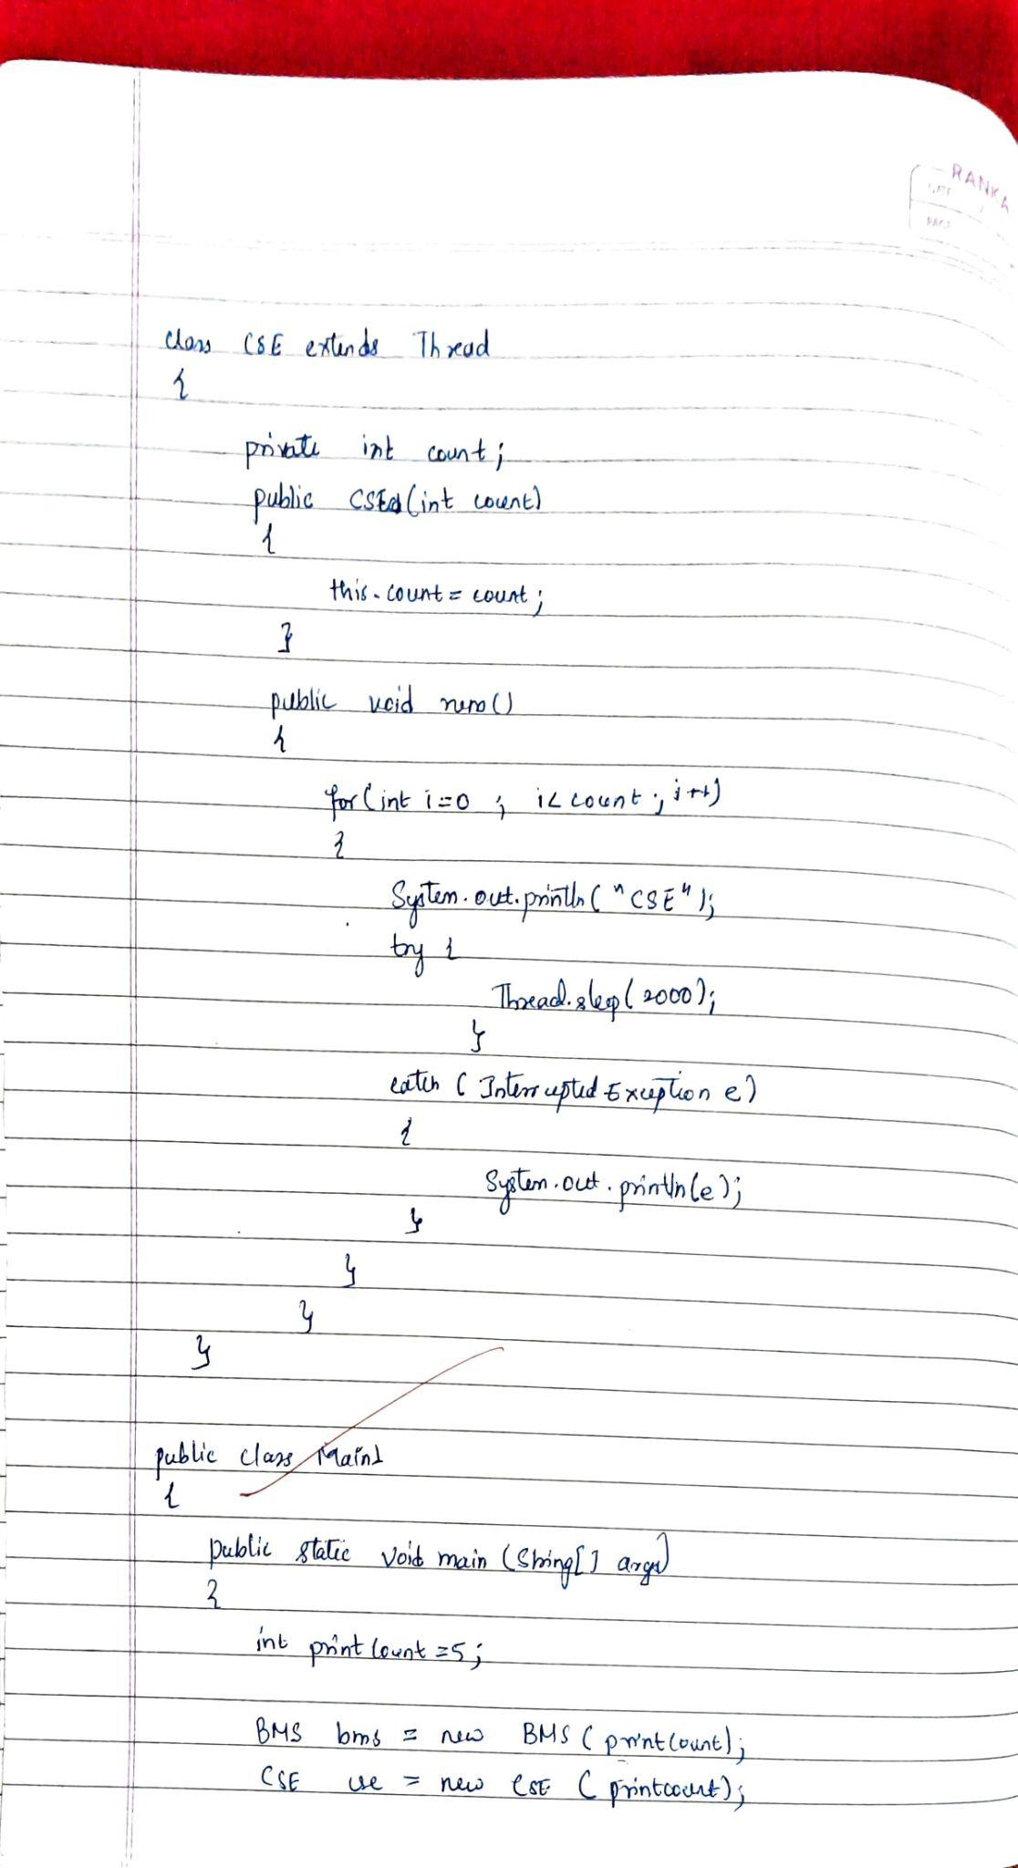

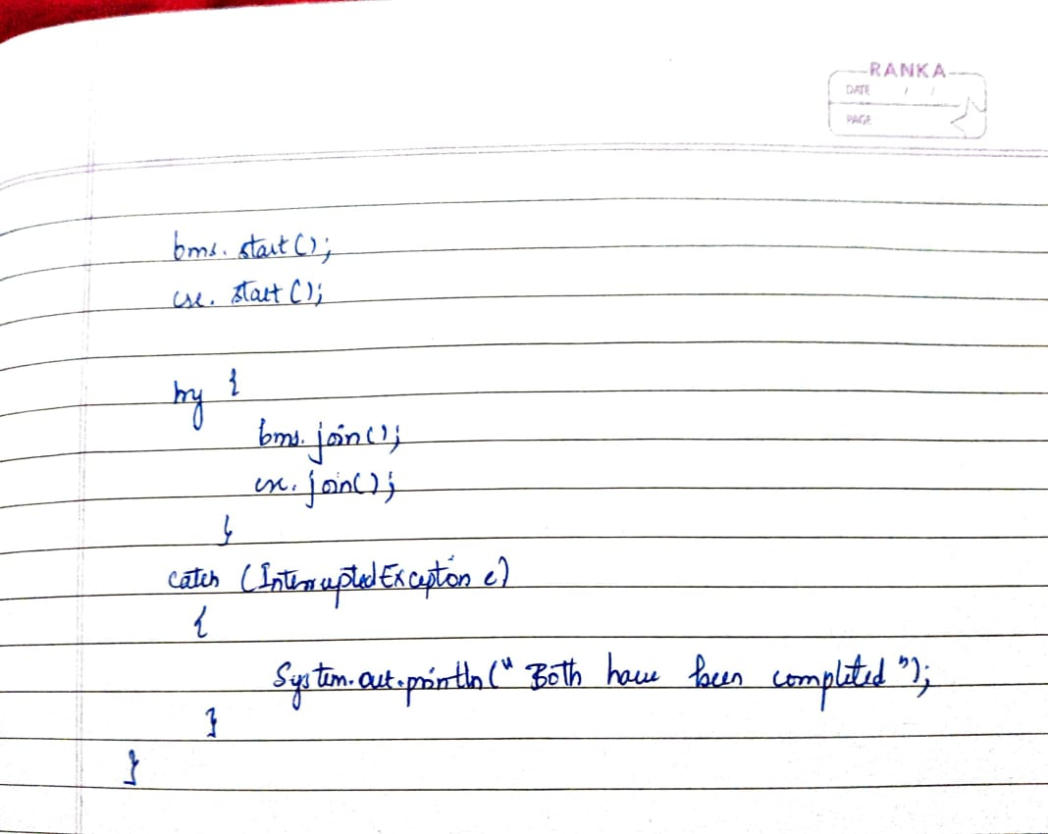

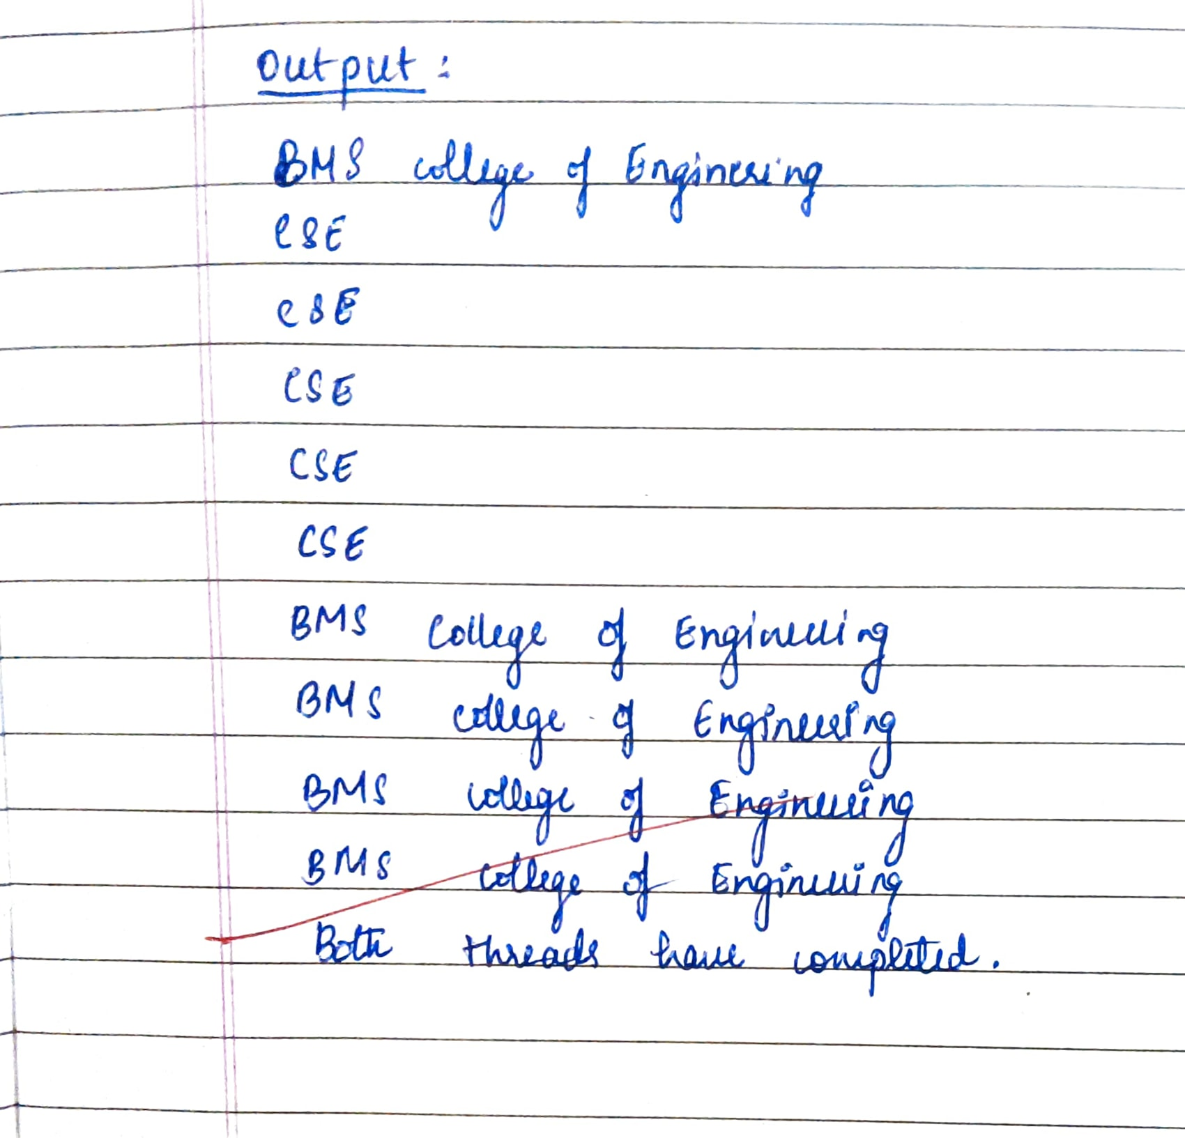

Code:

class BMSThread extends Thread {

private int count;

public BMSThread(int count) {

this.count = count;

}

@Override

public void run() {

for (int i = 0; i < count; i++) {

System.out.println("BMS College of Engineering");

try {

Thread.sleep(10000); // Sleep for 10 seconds

} catch (InterruptedException e) {

System.out.println(e);

}

}

}

}

class CSEThread extends Thread {

private int count;

public CSEThread(int count) {

this.count = count;

}

public void run() {

for (int i = 0; i < count; i++) {

System.out.println("CSE");

try {

Thread.sleep(2000); // Sleep for 2 seconds

} catch (InterruptedException e) {

System.out.println(e);

}

}

}

}

public class Bmscse {

public static void main(String[] args) {

int printCount = 5; // Number of times each message should be printed

// Create two threads

BMSThread bmsThread = new BMSThread(printCount);

CSEThread cseThread = new CSEThread(printCount);

// Start both threads

bmsThread.start();

cseThread.start();

// Wait for both threads to finish

try {

bmsThread.join();

cseThread.join();

} catch (InterruptedException e) {

System.out.println(e);

}

// Print completion message

System.out.println("Both threads have completed.");

}

}

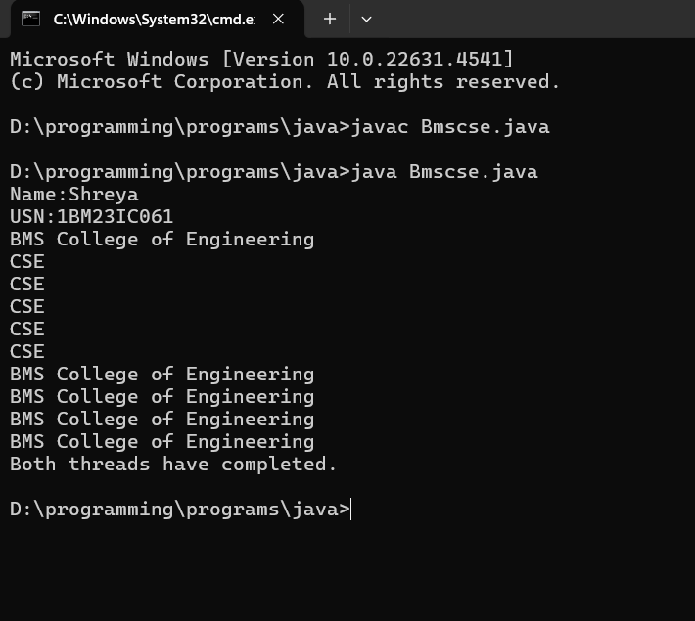

**Program 9**

Write a program that creates a user interface to perform integer divisions.The user enters two numbers in the text fields, Num1 and Num2. The division of Num1 and Num2 is displayed in the Result field when the Divide button is clicked. If Num1 or Num2 were not an integer, the program would throw a NumberFormatException. If Num2 were Zero, the program would throw an Arithmetic Exception Display the exception in a message dialog box.

Algorithm:

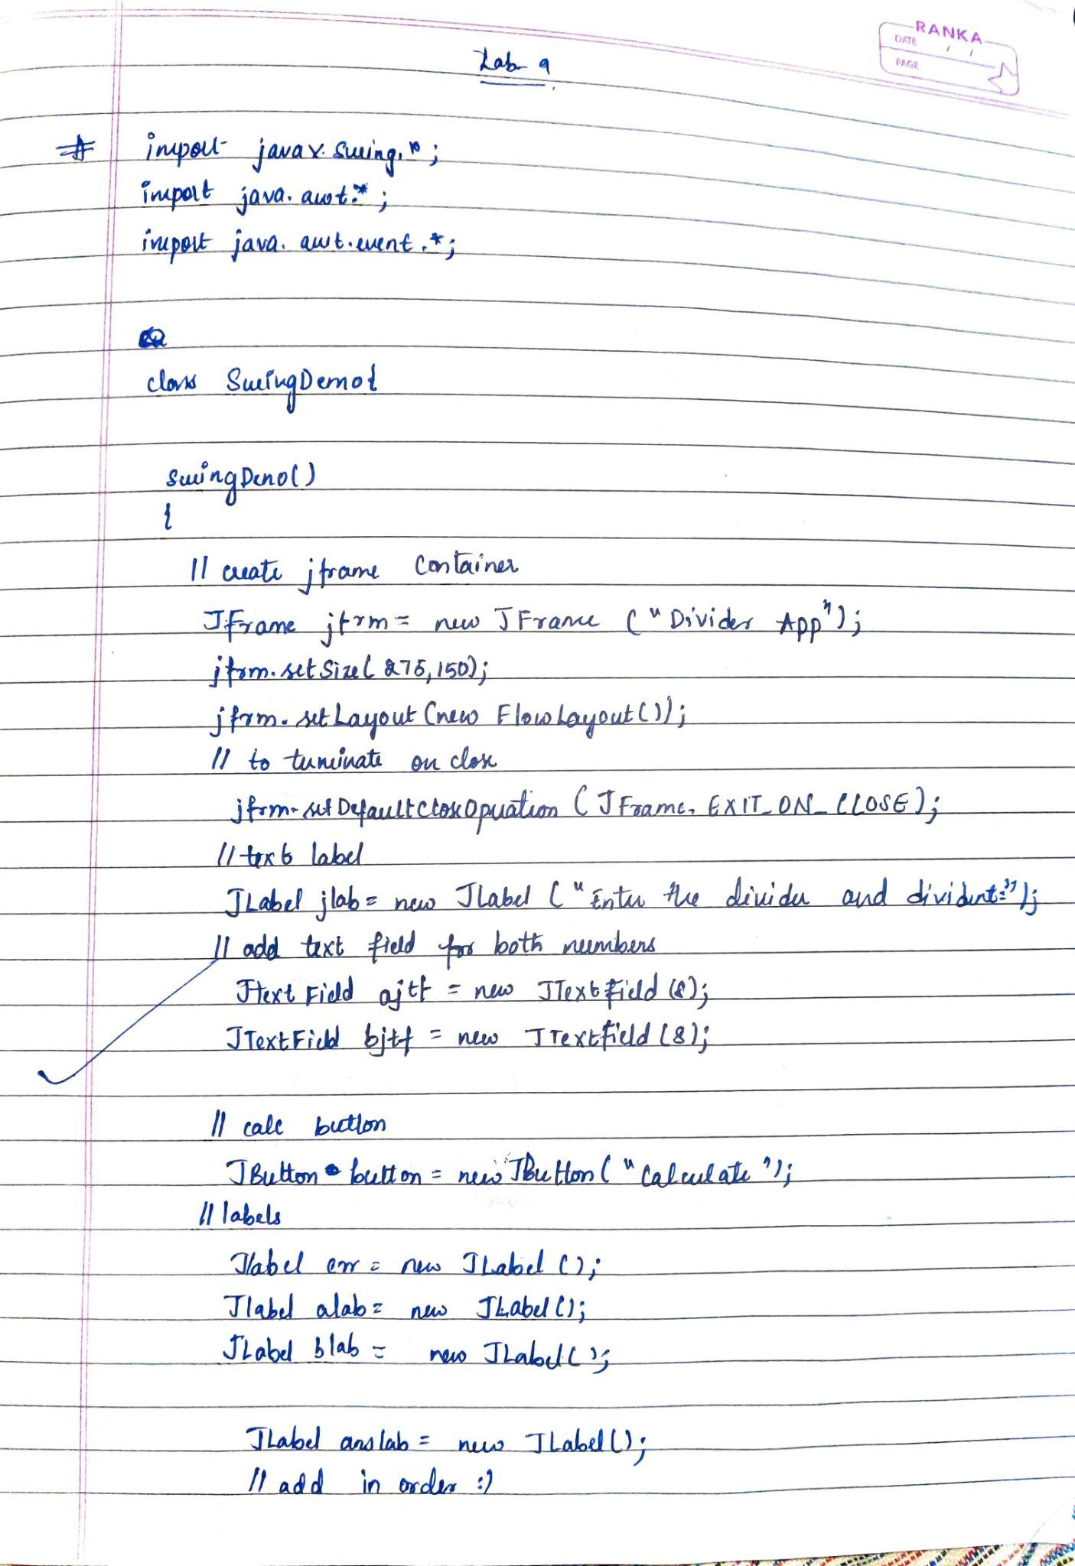

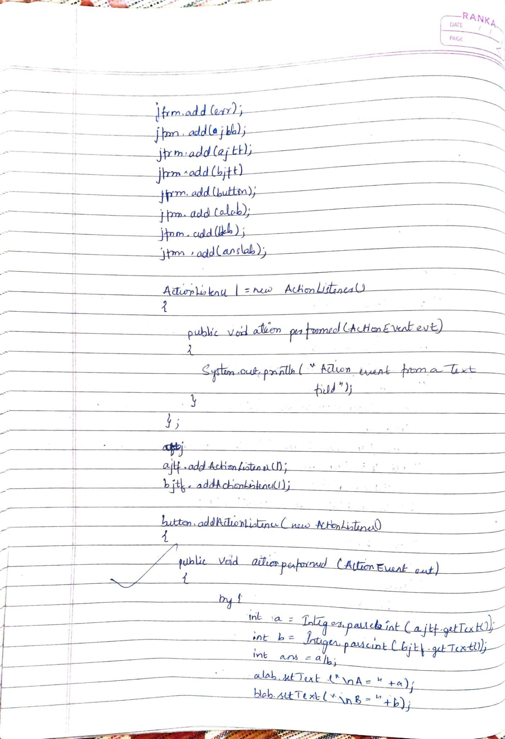

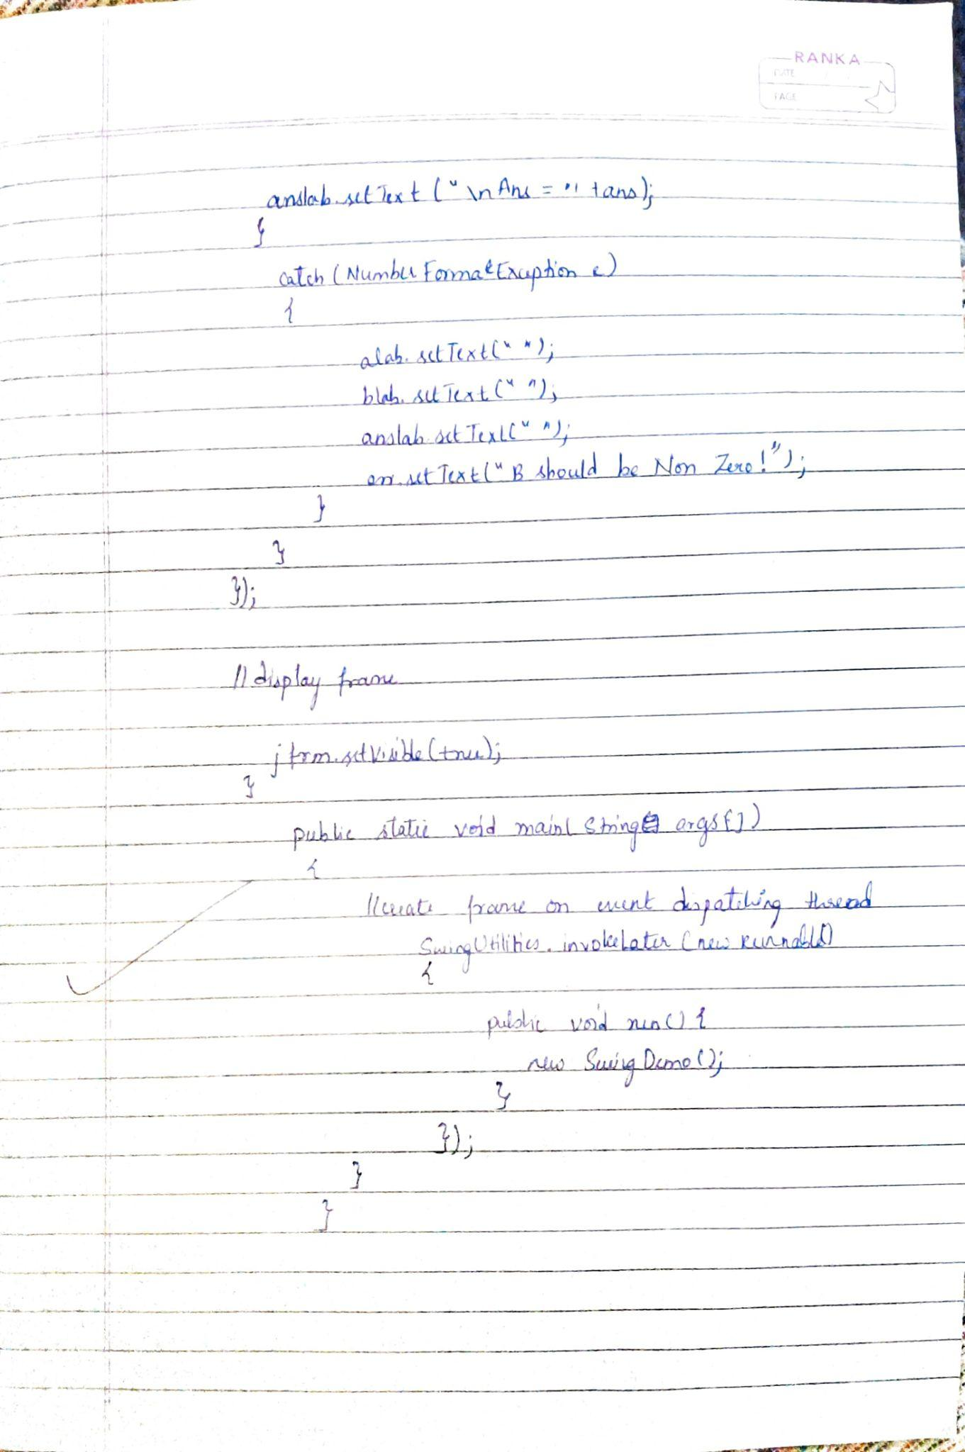

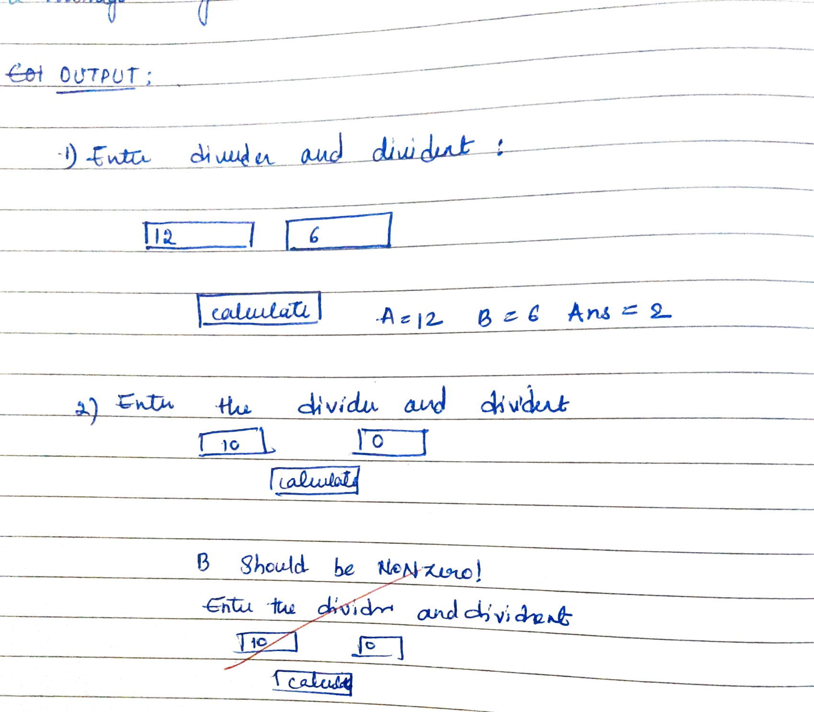

Code:

import javax.swing.*;

import java.awt.*;

import java.awt.event.*;

class SwingDemo{

SwingDemo(){

// create jframe container

JFrame jfrm = new JFrame("Divider App");

jfrm.setSize(275, 150);

jfrm.setLayout(new FlowLayout());

// to terminate on close

jfrm.setDefaultCloseOperation(JFrame.EXIT_ON_CLOSE);

// text label

JLabel jlab = new JLabel("Enter the divider and divident:");

// add text field for both numbers

JTextField ajtf = new JTextField(8);

JTextField bjtf = new JTextField(8);

// calc button

JButton button = new JButton("Calculate");

// labels

JLabel err = new JLabel();

JLabel alab = new JLabel();

JLabel blab = new JLabel();

JLabel anslab = new JLabel();

// add in order :)

jfrm.add(err); // to display error bois

jfrm.add(jlab);

jfrm.add(ajtf);

jfrm.add(bjtf);

jfrm.add(button);

jfrm.add(alab);

jfrm.add(blab);

jfrm.add(anslab);

ActionListener l = new ActionListener() {

public void actionPerformed(ActionEvent evt) {

System.out.println("Action event from a text field");

}

};

ajtf.addActionListener(l);

bjtf.addActionListener(l);

button.addActionListener(new ActionListener() {

public void actionPerformed(ActionEvent evt) {

try{

int a = Integer.parseInt(ajtf.getText());

int b = Integer.parseInt(bjtf.getText());

int ans = a/b;

alab.setText("\nA = " + a);

blab.setText("\nB = " + b);

anslab.setText("\nAns = "+ ans);

}

catch(NumberFormatException e){

alab.setText("");

blab.setText("");

anslab.setText("");

err.setText("Enter Only Integers!");

}

catch(ArithmeticException e){

alab.setText("");

blab.setText("");

anslab.setText("");

err.setText("B should be NON zero!");

}

}

});

// display frame

jfrm.setVisible(true);

}

public static void main(String args[]){

// create frame on event dispatching thread

SwingUtilities.invokeLater(new Runnable(){

public void run(){

new SwingDemo();

}

});

}

}

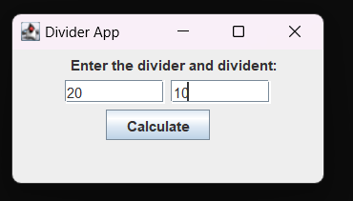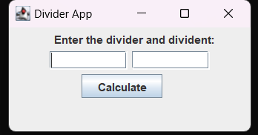

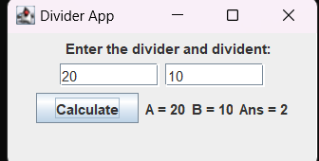

**Program 10**

Demonstrate Inter process Communication and deadlock

Algorithm:

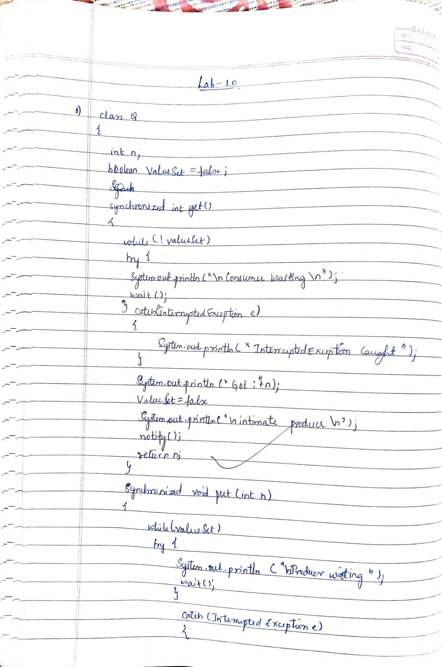

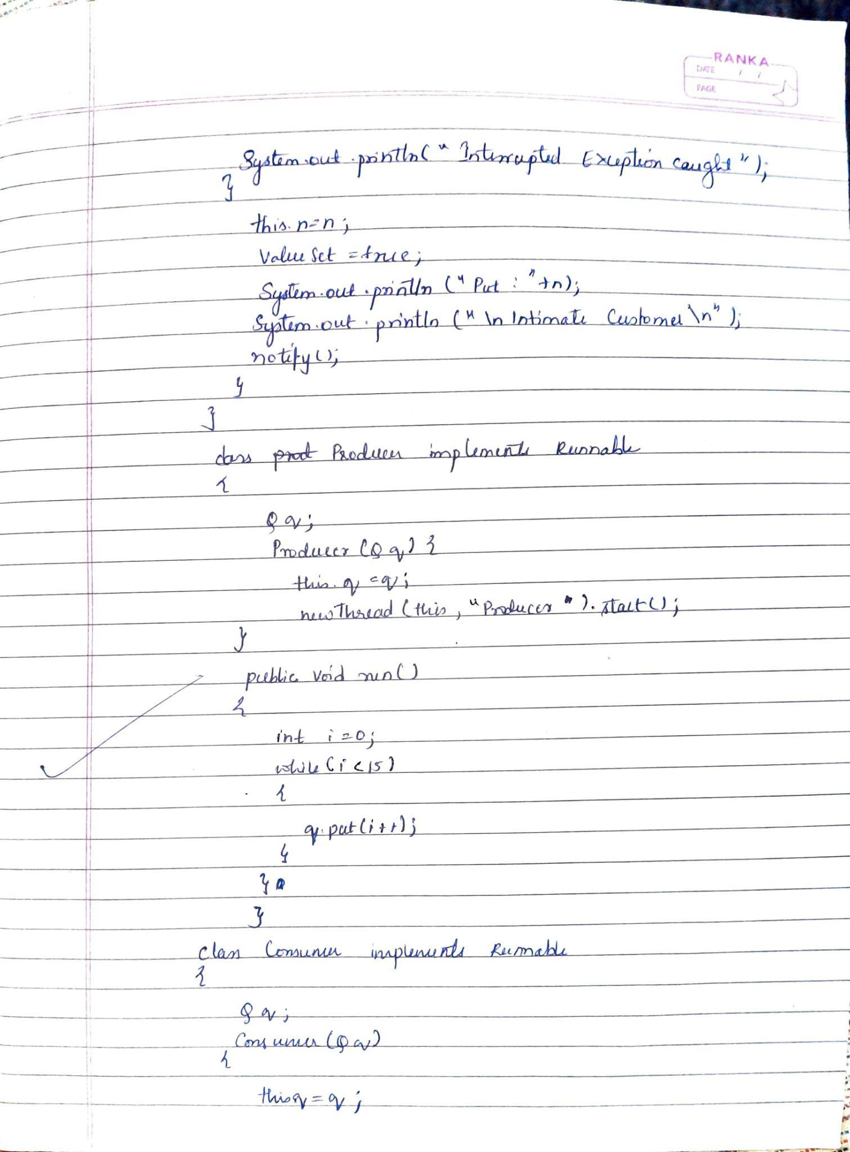

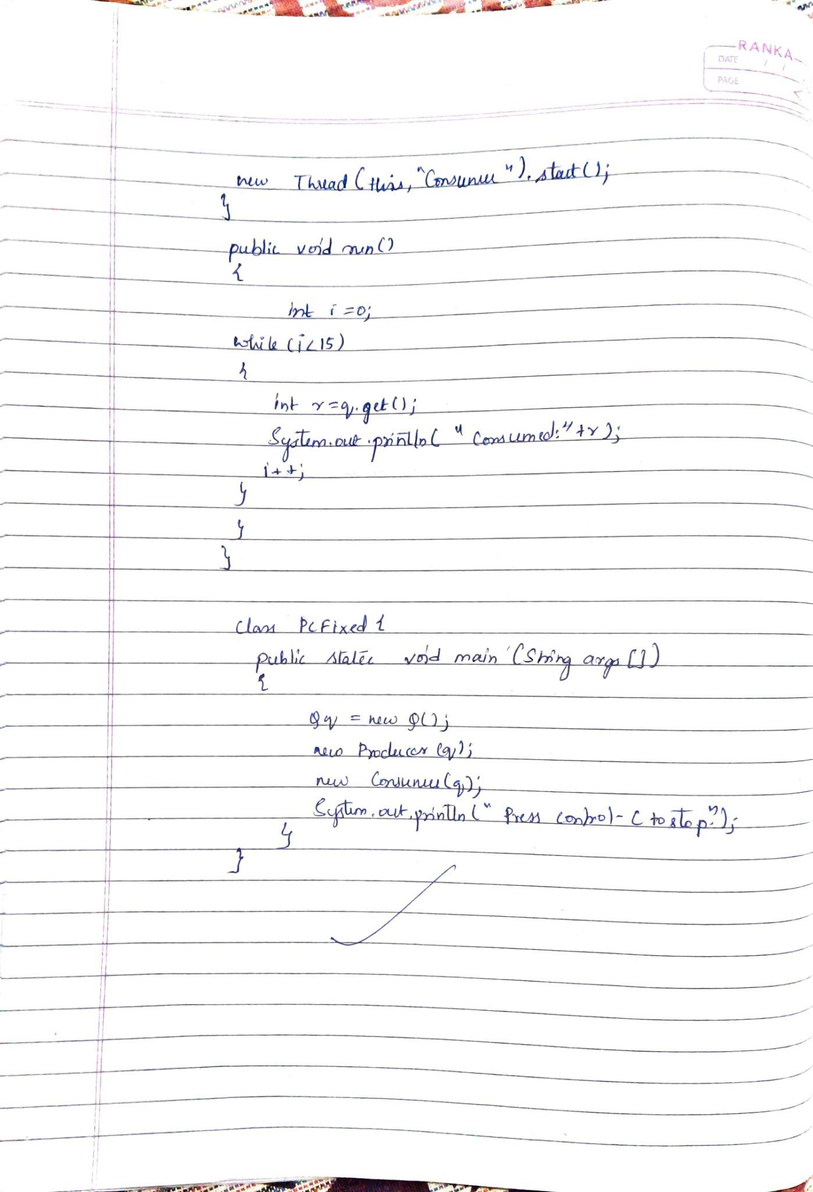

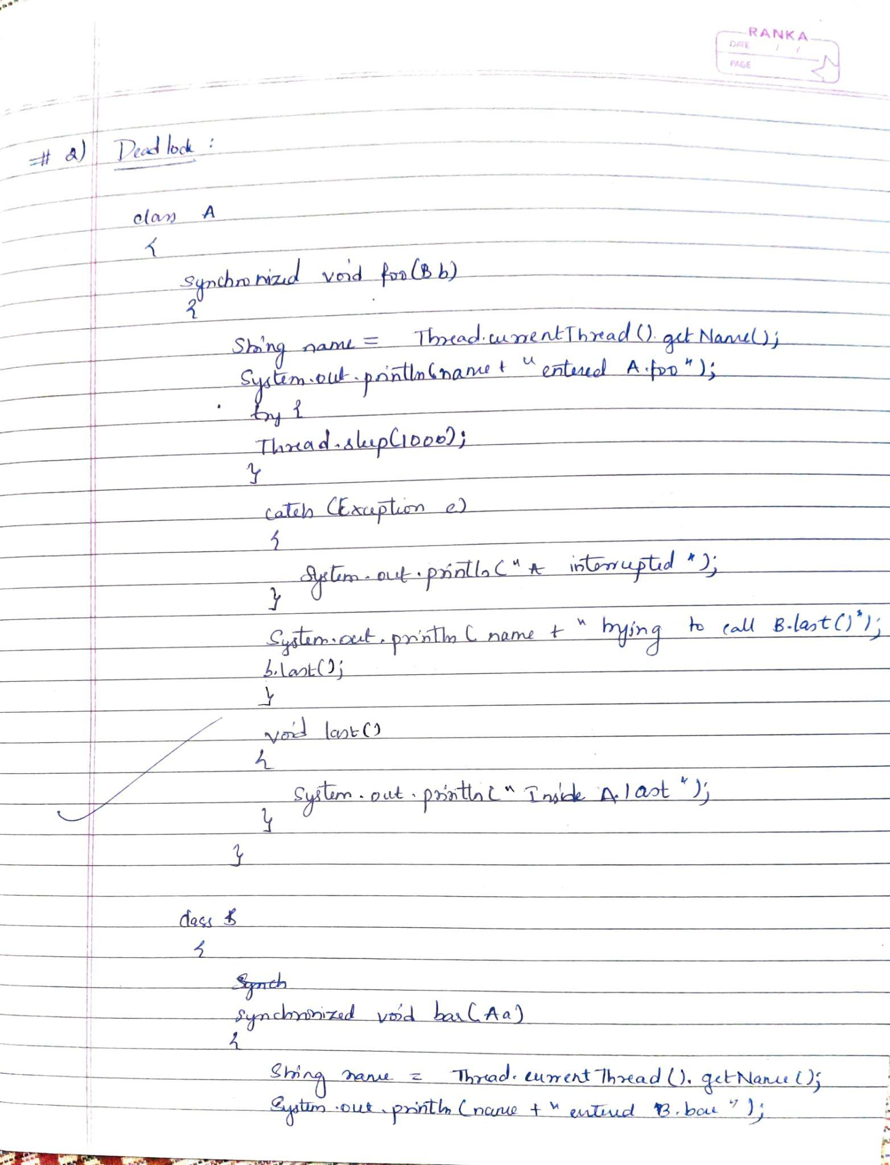

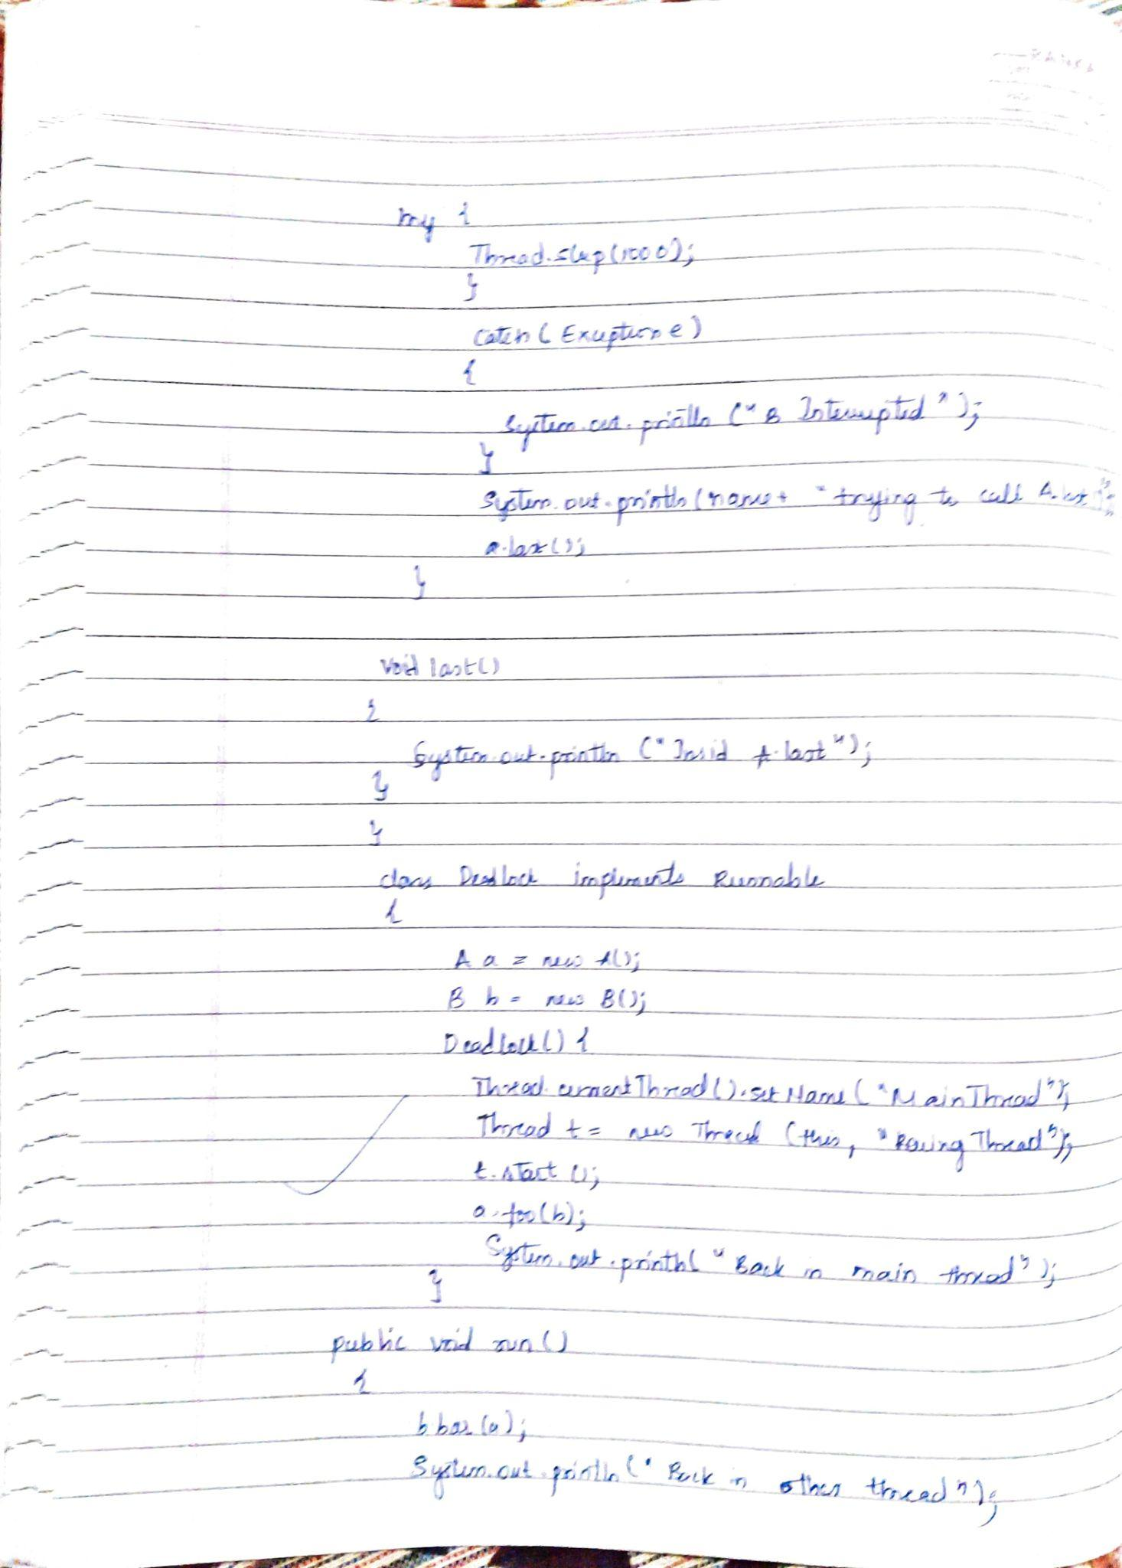

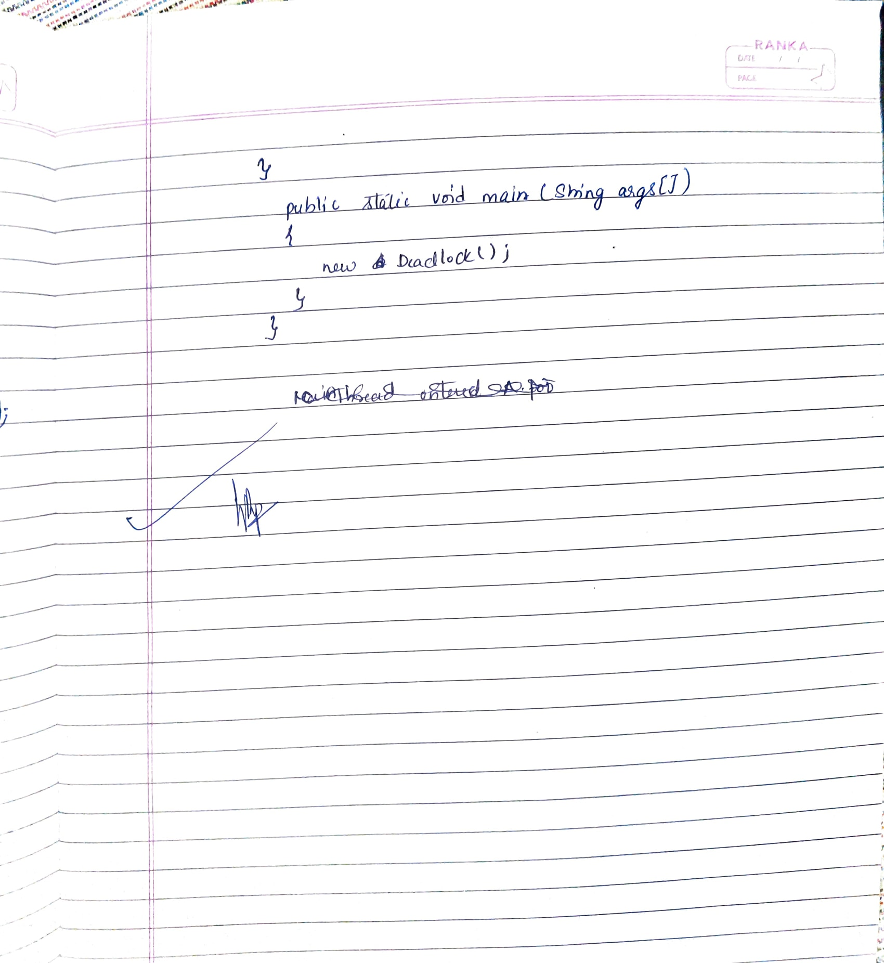

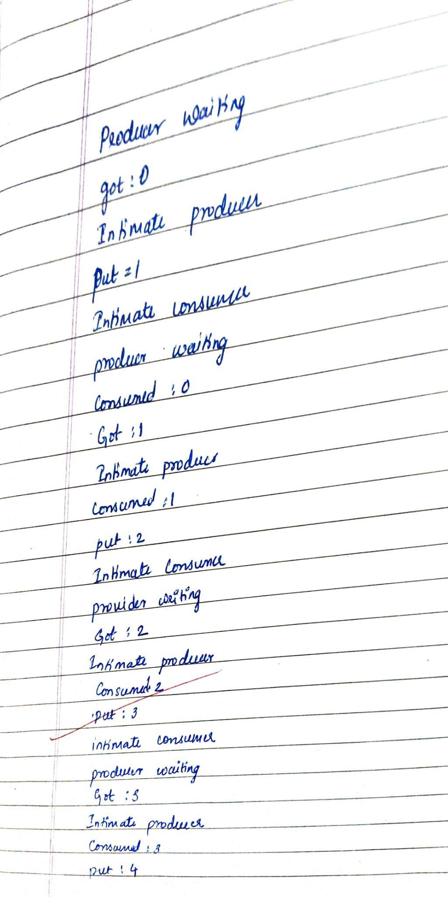

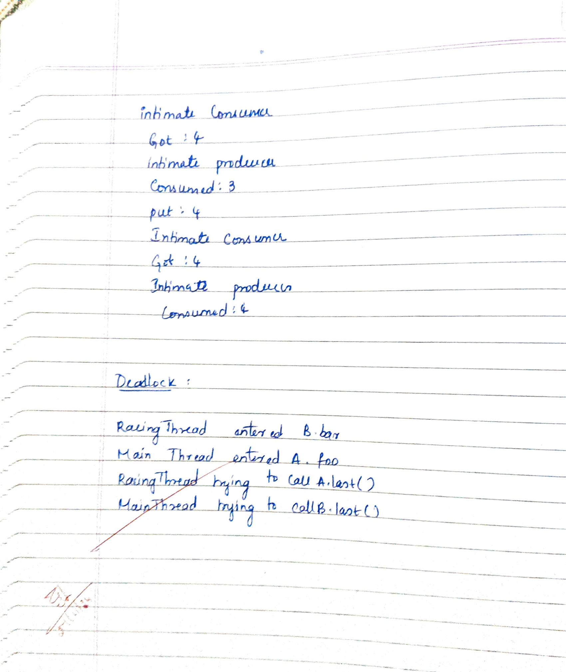

Code:

1.Interface:

class Q {

int n;

boolean valueSet = false;

// Synchronized method to get the value

synchronized int get() {

while (!valueSet) {

try {

System.out.println("\nConsumer waiting...");

wait(); // Consumer waits until a value is produced

} catch (InterruptedException e) {

System.out.println("InterruptedException caught");

}

}

// Consume the product

System.out.println("Got: " + n);

valueSet = false;

// Notify the producer that consumer has consumed the product

System.out.println("\nIntimate Producer...");

notify();

return n;

}

// Synchronized method to put the value

synchronized void put(int n) {

while (valueSet) {

try {

System.out.println("\nProducer waiting...");

wait(); // Producer waits until the consumer consumes the product

} catch (InterruptedException e) {

System.out.println("InterruptedException caught");

}

}

// Produce a product

this.n = n;

valueSet = true;

System.out.println("Put: " + n);

// Notify the consumer that the producer has put a new product

System.out.println("\nIntimate Consumer...");

notify();

}

}

class Producer implements Runnable {

Q q;

Producer(Q q) {

this.q = q;

new Thread(this, "Producer").start(); // Create and start the producer thread

}

public void run() {

int i = 0;

while (i < 15) {

q.put(i++); // Producer puts a value into the queue

}

}

}

class Consumer implements Runnable {

Q q;

Consumer(Q q) {

this.q = q;

new Thread(this, "Consumer").start(); // Create and start the consumer thread

}

public void run() {

int i = 0;

while (i < 15) {

int r = q.get(); // Consumer gets a value from the queue

System.out.println("Consumed: " + r);

i++;

}

}

}

class PCFixed {

public static void main(String args[]) {

Q q = new Q(); // Shared queue between producer and consumer

new Producer(q); // Start the producer thread

new Consumer(q); // Start the consumer thread

System.out.println("Press Control-C to stop.");

}

}

2.Deadlock:

class A {

synchronized void foo(B b) {

String name = Thread.currentThread().getName();

System.out.println(name + " entered A.foo");

try {

Thread.sleep(1000); // Simulate some work

} catch (Exception e) {

System.out.println("A Interrupted");

}

System.out.println(name + " trying to call B.last()");

b.last(); // Call method in B

}

synchronized void last() {

System.out.println("Inside A.last");

}

}

class B {

synchronized void bar(A a) {

String name = Thread.currentThread().getName();

System.out.println(name + " entered B.bar");

try {

Thread.sleep(1000); // Simulate some work

} catch (Exception e) {

System.out.println("B Interrupted");

}

System.out.println(name + " trying to call A.last()");

a.last(); // Call method in A

}

synchronized void last() {

System.out.println("Inside B.last");

}

}

class Deadlock implements Runnable {

A a = new A();

B b = new B();

Deadlock() {

Thread.currentThread().setName("MainThread");

Thread t = new Thread(this, "RacingThread");

t.start(); // Start the second thread

a.foo(b); // Main thread locks A and tries to call B's last() method

System.out.println("Back in main thread");

}

public void run() {

b.bar(a); // Other thread locks B and tries to call A's last() method

System.out.println("Back in other thread");

}

public static void main(String[] args) {

new Deadlock(); // Start the deadlock simulation

}

}

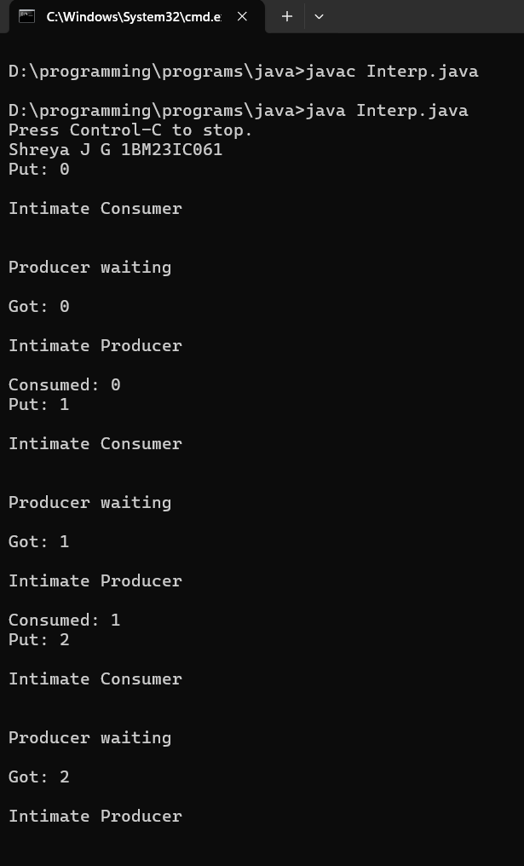

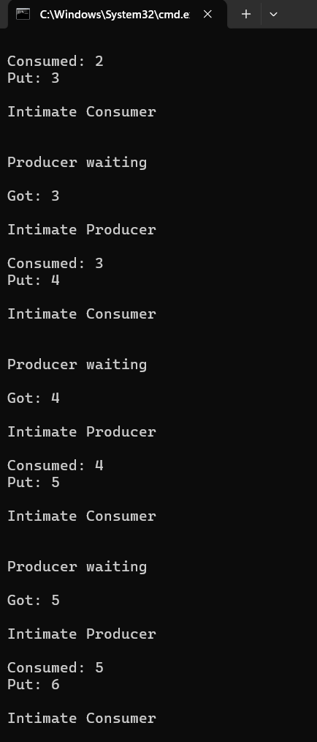

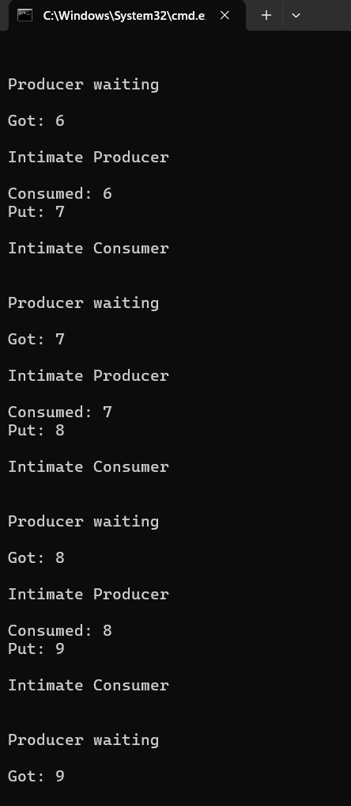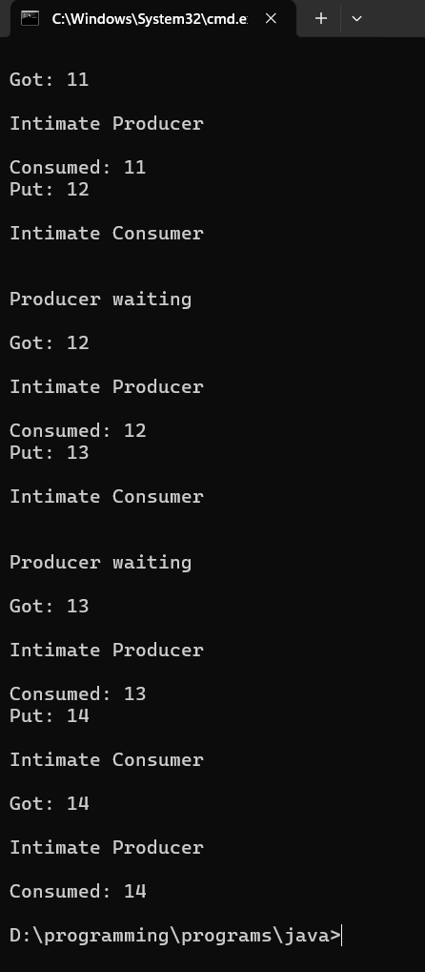llast output of interprocess and deadlock